Tool | A few descriptive statistics from English teachers' data
Data Dump | 6th September
Preliminary analysis done by | Arundhati

1. I feel that teaching English is about:
 | Strongly agree | Agree | No opinion | Disagree | Strongly Disagree
Making students read aloud from the textbook. | 33.83 | 63.16 | 3.01
Making students memorise the rules of grammar. | 35.34 | 49.62 | 1.50 | 11.28 | 2.26
Teaching the content given in the textbook. | 27.82 | 61.65 | 3.76 | 6.77
Connecting the textbook material with students’ experience. | 33.83 | 63.16 | 3.01
Making students listen to and speak English. | 59.40 | 37.59 | 0.75 | 2.26
Focusing on literature. | 17.29 | 59.40 | 9.77 | 12.78 | 0.75
Focusing on language use (Grammar, etc). | 37.59 | 58.65 | 1.50 | 2.26

2. I believe that:
 | Strongly agree | Agree | No opinion | Disagree | Strongly Disagree
Students who find English difficult, do not try enough to learn. | 17.29 | 58.65 | 6.02 | 17.29 | 0.75
Students need exposure to more spoken English to improve. | 45.11 | 52.63 | 2.26
Students mother tongue should not be used in the English classroom. | 15.79 | 42.86 | 3.76 | 36.84 | 0.75
Science and Mathematics are of more practical use than English for our students. | 7.52 | 33.08 | 10.53 | 43.61 | 5.26
For some reason girls are better at using English than boys. | 6.02 | 43.61 | 15.79 | 33.83 | 0.75
Games and activities are suitable for primary school, not for high school  classes. | 3.76 | 24.06 | 11.28 | 57.14 | 3.76
Discussions in class disrupt discipline and distract students. | 3.01 | 30.08 | 8.27 | 52.63 | 6.02
Students can learn on their own, if given guidance. | 17.29 | 73.68 | 3.76 | 5.26
My students can easily understand English films / TV Programmes. | 5.26 | 43.61 | 13.53 | 36.84 | 0.75
Students should be corrected for mistakes they make, as soon as they  make these mistakes. | 12.03 | 63.91 | 6.02 | 16.54 | 1.50
Teaching English is difficult. | 5.26 | 30.08 | 7.52 | 51.88 | 5.26
Assessments are tough to do. | 4.51 | 40.60 | 11.28 | 40.60 | 3.01
We should spend more time teaching other subjects than English. | 6.02 | 23.31 | 8.27 | 57.14 | 5.26
We should avoid giving homework in English as much as possible. | 2.26 | 14.29 | 2.26 | 72.93 | 8.27
I need to improve my English, so that I can teach it better. | 29.32 | 64.66 | 2.26 | 3.76
English teachers are given more respect than other teachers. | 3.01 | 27.82 | 25.56 | 42.11 | 1.50

3. In the English classroom that I teach:
 | Strongly agree | Agree | No opinion | Disagree | Strongly Disagree
3.1.I have no time to do additional activities, because I have to cover all  content in the textbook. | 7.52 | 39.10 | 4.51 | 48.12 | 0.75
3.2.Making students give personal opinions about the text is not useful. | 3.76 | 27.82 | 14.29 | 51.88 | 2.26
3.3.Boys answer questions more frequently than girls. | 3.01 | 15.04 | 9.77 | 70.68 | 1.50
3.4.When students make mistakes, the best remedy is to give them repeated  practice of similar spellings or sentence structures. | 18.80 | 73.68 | 1.50 | 6.02
3.5.Films / Radio clippings are not necessary materials in the English class. | 2.26 | 9.77 | 9.02 | 72.18 | 6.77

4. In the English classroom:
 | Always; | Frequently | Sometimes | Never
4.1.I discuss the answers and ask the students to write their own answers. | 38.35 | 29.32 | 32.33
4.2.I organise learning activities (games, puzzles, role plays) with the students. | 15.04 | 24.06 | 51.13 | 9.77
4.3.I do activities that involve group work that allow students to see, share and discuss their class work or home work with each other | 21.80 | 31.58 | 40.60 | 6.02
4.4.I maintain silence/ discipline because students must concentrate and individually understand the English lesson / concept. | 51.88 | 23.31 | 24.06 | 0.75
4.5.I encourage students to come up with their own ideas about how to answer questions. | 65.41 | 24.81 | 9.77
4.6.I encourage students to watch news / TV programmes / films in English. | 57.14 | 22.56 | 19.55 | 0.75
4.7.I use recent newspaper articles as teaching materials. | 16.54 | 26.32 | 49.62 | 7.52

5. How well prepared do you feel you are to teach the following topics?
Prose | Not well prepared | Somewhat prepared | Very well prepared | Not applicable
5.1.1.Narratives / Short Stories | 3.01 | 39.10 | 57.89
5.1.2.Non Fiction (Biographies / Letters / Informative passages) | 2.26 | 42.86 | 53.38 | 1.50
5.1.3.Open Ended Stories | 5.26 | 55.64 | 36.09 | 3.01
5.1.4.Prose by Indian writers | 2.26 | 41.35 | 52.63 | 3.76
5.1.5.Prose by non-Indian writers | 6.77 | 49.62 | 39.10 | 4.51

Poetry | Not well prepared | Somewhat prepared | Very well prepared | Not applicable
5.2.1. Short Poems | 2.26 | 40.60 | 54.14 | 3.01
5.2.2.Form-based poems such as Sonnets, etc. | 7.52 | 39.10 | 48.12 | 5.26
5.2.3.Classic English poets such as Shakespeare | 10.53 | 34.59 | 50.38 | 4.51
5.2.4.Classic Indian poets such as Rabindranath Tagore, Sarojini Naidu | 4.51 | 39.85 | 51.88 | 3.76
5.2.5.Modern Poetry | 7.52 | 46.62 | 39.85 | 6.02
5.2.6.Poems based on emotions (love, anger, pain) | 3.76 | 40.60 | 53.38 | 2.26
5.2.7.Poems based on issues (environment, unity) | 3.76 | 37.59 | 56.39 | 2.26

Drama | Not well prepared | Somewhat prepared | Very well prepared | Not applicable
5.3.1.Drama extracts by Indian Playwrights | 7.52 | 40.60 | 43.61 | 8.27
5.3.2.Translations from Indian languages | 5.26 | 45.11 | 46.62 | 3.01
5.3.3.Drama only when it can be enacted in the class. | 10.53 | 53.38 | 27.07 | 9.02

Reading and Writing Tasks | Not well prepared | Somewhat prepared | Very well prepared | Not applicable
5.4.1.Comprehension | 2.26 | 39.85 | 57.14 | 0.75
5.4.2.Paragraph Writing | 3.76 | 37.59 | 57.89 | 0.75
5.4.3.Essays | 2.26 | 43.61 | 53.38 | 0.75
5.4.4.Letter Writing |  | 35.34 | 63.91 | 0.75
5.4.5.Summary / Précis Writing | 3.76 | 41.35 | 50.38 | 4.51
5.4.6.Report | 4.51 | 33.83 | 57.89 | 3.76
Writing for a purpose (agenda, notice, minutes, advertisements,  articles, etc.) | 3.01 | 40.60 | 50.38 | 6.02

5.5. Listening and Speaking Tasks | Not well prepared | Somewhat prepared | Very well prepared | Not applicable
5.5.1.Comprehension | 0.75 | 42.11 | 54.89 | 2.26
5.5.2.Note Taking | 4.51 | 44.36 | 45.11 | 6.02
5.5.3.Practising Social Conversation | 6.77 | 53.38 | 32.33 | 7.52
5.5.4.Understanding and speaking for functional purposes (directions, instructions) | 6.02 | 48.87 | 39.85 | 5.26
5.5.5.Describing / narrating / reporting | 2.26 | 45.86 | 48.12 | 3.76
5.5.6.Debating / Presenting an argument | 6.77 | 45.11 | 35.34 | 12.78

5.6. Language Use and Stylistic Devices | Not well prepared | Somewhat prepared | Very well prepared | Not applicable
5.6.1.Grammatical correctness | 0.75 | 44.36 | 54.14 | 0.75
5.6.2.Appropriate communication | 6.02 | 49.62 | 42.11 | 2.26
5.6.3.Polite expressions | 0.75 | 42.11 | 55.64 | 1.50
5.6.4.Literal and figurative speech | 12.78 | 46.62 | 33.83 | 6.77
5.6.5.Literary language | 10.53 | 45.11 | 38.35 | 6.02

How would you characterize each of the following within your school?
 | Very low | low | Medium | high | Very high
6.1.Teachers’ job satisfaction |  | 1.50 | 44.36 | 36.84 | 17.29
6.2.Teachers’ understanding of the school’s curricular goals |  | 3.01 | 42.11 | 45.86 | 9.02
6.3.Teachers’ degree of success in implementing the school’s curriculum |  | 1.50 | 51.13 | 40.60 | 6.77
6.4.Teachers’ expectations for student achievement |  | 0.75 | 35.34 | 50.38 | 13.53
6.5.Parental support for student achievement | 12.78 | 27.82 | 32.33 | 20.30 | 6.77
6.6.Parental involvement in school activities | 18.80 | 34.59 | 30.83 | 12.03 | 3.76
6.7.Students’ regard for school property | 3.01 | 17.29 | 51.88 | 21.80 | 6.02
6.8.Students’ desire to do well in school | 2.26 | 9.77 | 53.38 | 28.57 | 6.02

How often do you have the following types of interactions with other teachers?
 | Daily or almost daily | 1-3 times per week | 2 or 3 times per month | (almost) Never
7.1.Discussions about how to teach a particular concept | 30.08 | 30.83 | 34.59 | 4.51
7.2.Working on preparing lesson plans | 54.89 | 18.80 | 23.31 | 3.01
7.3.Visits to another teacher’s classroom to observe his/her teaching | 4.51 | 12.03 | 28.57 | 54.89
7.4.Informal observations of my classroom by another teacher | 6.77 | 11.28 | 30.08 | 51.88
7.5.Discussions with other subject teachers to integrate English with other disciplines | 15.04 | 21.80 | 42.86 | 20.30

In the past two years, have you participated in professional development training/workshops in any of the following?
 | Yes | No
8.1.English curricular content. | 60.15 | 39.85
8.2.English pedagogy/instruction. | 53.38 | 46.62
8.3.Integrating information technology into English Teaching. | 42.11 | 57.89
8.4.Improving students’ critical thinking or problem solving skills. | 51.13 | 48.87
8.5.Methods of Assessment. | 56.39 | 43.61

9.In the Class 9 that you teach, how many students are there?
Average number of students 71. But there are 3 outliers with 1 school having only 3 students and 2 schools having 500 students each.

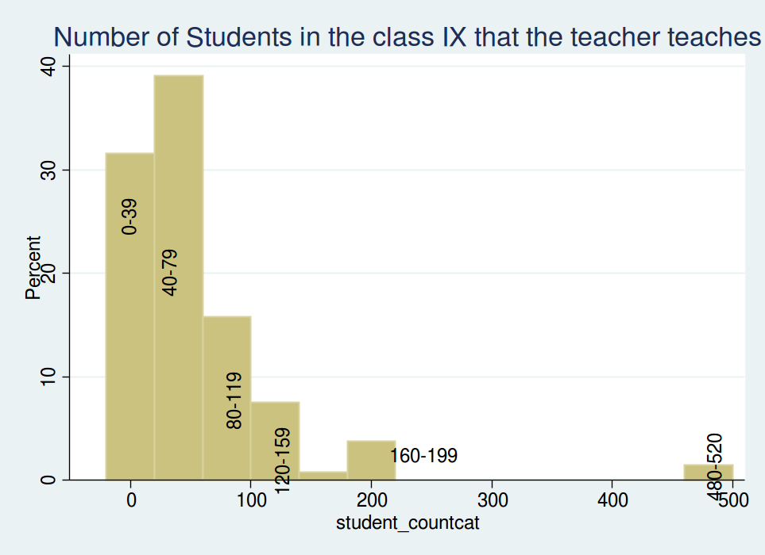
10.How many hours per week do you teach English to the Class 9?
While on an average 17 hours/week is being spent by teachers teaching English to class IX, the range varies from a minimum of 2 hours by 2 teachers to maximum of 270 hours also by 2 teachers.

 | As the primary basis for my lessons | As a supplementary resource; | Do not use
11.How do you use a textbook(s) in teaching English to the Class 9? | 65.41 | 33.83 | 0.75

13.In teaching English to the students in the class 9, how often do you usually ask them to do the following?
13.In teaching English to the students in the class 9, how often do you usually ask them to do the following? | Never | Some lessons | About half the lessons | (Almost) every lesson
13.1.Memorize rules and formulas (spellings, grammar rules, etc.) | 3.76 | 43.61 | 6.77 | 45.86
13.2.Apply facts, concepts and rules to complete tasks (role play, letter writing,) | 2.26 | 63.16 | 8.27 | 26.32
13.3.Explain their answers | 5.26 | 33.08 | 12.78 | `48.87
13.4.Relate what they are learning in English lessons to their daily lives | 4.51 | 42.11 | 6.77 | 46.62
13.5.Read their textbooks and other resource material. | 1.50 | 39.10 | 6.02 | 53.38
13.6.Decide on their own procedures to complete tasks / answer questions. | 6.02 | 42.11 | 12.03 | 39.85
13.7.Work on problems for which there is no immediately obvious method of solution | 14.29 | 56.39 | 6.77 | 22.56
13.8.Work together in small groups | 10.53 | 53.38 | 10.53 | 25.56
13.9.Find information and present to the class the next day. (Meanings, facts, etc.) | 4.51 | 39.10 | 9.02 | 47.37

14.In your view, to what extent do the following conditions limit how you teach English for class 9?
14.1.Students | A lot | Some | A little | Not at all; | Not applicable
14.1.1.Students with different academic abilities. | 24.06 | 57.89 | 13.53 | 3.76 | 0.75
14.1.2.Students come from a wide range of backgrounds (example economic, language). | 39.85 | 39.10 | 14.29 | 6.02 | 0.75
14.1.3.Students with special needs (e.g., hearing, vision, speech impairment, physical disabilities, mental or emotional/psychological impairment). | 17.29 | 25.56 | 33.08 | 18.80 | 5.26
14.1.4.Uninterested students.. | 14.29 | 49.62 | 27.82 | 5.26 | 3.01
14.1.5.Disruptive students. | 3.76 | 57.89 | 26.32 | 8.27 | 3.76

14.2.Resources | A lot | Some | A little | Not at all; | Not applicable
14.2.1.Shortage of computer hardware. | 32.33 | 26.32 | 12.78 | 12.78 | 15.79
14.2.2.Shortage of computer software. | 34.59 | 30.08 | 13.53 | 6.77 | 15.04
14.2.3.Shortage of support for using computers. | 33.83 | 28.57 | 15.79 | 9.02 | 12.78
14.2.4.Shortage of textbooks for student use. | 9.77 | 18.05 | 15.04 | 51.88 | 5.26
14.2.5.Shortage of other instructional equipment for students’ use. | 21.05 | 38.35 | 21.05 | 15.04 | 4.51
14.2.6.Shortage of equipment for your use in demonstrations and other exercises. | 21.05 | 42.11 | 19.55 | 12.03 | 5.26
14.2.7.Inadequate physical facilities. | 17.29 | 42.86 | 21.05 | 14.29 | 4.51
14.2.8.High student/teacher ratio. | 9.77 | 36.09 | 27.82 | 22.56 | `3.76
14.2.9.Lack of audio-visual aids. | 39.85 | 25.56 | 15.79 | 13.53 | 5.26
14.2.10.Lack of support from peers and/or school administration. | 11.28 | 39.10 | 18.05 | 27.07 | 4.51
14.2.11.Shortage of reference material (books, newspapers) in English. | 18.05 | 38.35 | 23.31 | 17.29 | 3.01

 | Yes | No
16.Do students in Class 9 have computer(s) available to use during their English | 18.80 | 81.20
17.Do any of the computer(s) have access to the Internet? | 44.44 | 55.56

18.In teaching English to Class 9, how often do you have students use a computer for the following activities? | Never | Some lessons; | YesAbout half the lessons; | No
18.1.Discover Language principles and concepts | 53.38 | 39.85 | 0.75 | 6.02
18.2.Practice skills and procedures | 45.11 | 41.35 | 4.51 | 9.02
18.3.Look up ideas and information | 37.59 | 44.36 | 7.52 | 10.53
18.4.Access travelogues, newspapers, audio-visual clips, etc. | 50.38 | 39.85 | 3.76 | 6.02

19.How often do you usually assign English homework to the Class 9? | Every or almost every lesson | About half the lessons | Some lessons | Never
 | 75.19 | 9.77 | 15.04

20.When you assign English homework to class 9 students, about how many  minutes worth of work do you usually assign? (Consider the time it would  take an average student in your class. | Less than 15 minutes | 15-30 minutes; | 31-60 minutes; | 61-90 minutes; | More than 90 minutes
 | 23.31 | 49.62 | 20.30 | 4.51 | 2.26

21.How often do you assign the following kinds of English homework to class 9? | Never or almost never | Sometimes | Always or almost always
21.1.Solving questions given in the textbook. | 3.76 | 54.89 | 41.35
21.2.Gathering data and reporting. | 20.30 | 65.41 | 14.29
21.3.Finding one or more applications/variations of the content covered. | 12.03 | 76.69 | 11.28

22.How often do you do the following with the English homework? | Never or almost never | Sometimes | Always or almost always
22.1Monitor whether or not the homework was completed | 8.27 | 36.84 | 54.89
22.2.Correct assignments and then give feedback to students | 1.50 | 25.56 | 72.93
22.3.Have students correct their own homework in class | 17.29 | 60.90 | 21.80
22.4.Use the homework as a basis for class discussion | 6.77 | 66.17 | 27.07
22.5.Use the homework to contribute towards students’ grades or marks | 16.54 | 57.89 | 25.56

23.How much emphasis do you place on the following sources to monitor students’ progress in English?
 | No emphasis | Little emphasis | Some emphasis | Major emphasis
23.1.Classroom tests (for example, teacher made or textbook tests) | 3.01 | 12.78 | 57.14 | 27.07
23.2.National or regional achievement tests | 15.79 | 30.08 | 44.36 | 9.77
23.3.Your professional judgment | 3.01 | 16.54 | 61.65 | 18.80

24.How often do you include the following types of questions in your English tests or examinations?
 | Never or almost never | Sometimes | Always or almost always
24.1.Questions based on recall of facts and concepts | 3.41 | 72.73 | 23.86
24.2.Questions involving application of concepts (grammar) | 1.14 | 57.95 | 40.91
24.3.Questions on global comprehension. | 11.36 | 63.64 | 25.00
24.4.Questions requiring explanations or justifications not discussed in class. | 12.50 | 76.14 | 11.36

