Tool | A few descriptive statistics from Science teachers' data
Data Dump | 6th September
Preliminary analysis done by | Arundhati

How well prepared do you feel you are to teach the following topics?
Biology | Not well prepared | Somewhat prepared | Very well prepared | Not applicable
1.1.1.Major organs and organ systems in humans and other organisms (structure/function,life processes that maintain stable bodily conditions) | 1.55 | 39.53 | 43.41 | 15.50
1.1.2.Cells and their functions, including respiration and photosynthesis as cellular processes | 0.78 | 32.56 | 51.16 | 15.50
1.1.3.Reproduction (sexual and asexual) and heredity (passing on of traits, inherited versus acquired/ learned characteristics) | 2.33 | 27.91 | 54.26 | 15.50
1.1.4.Role of variation and adaptation in survival/extinction of species in a changing environment | 1.55 | 37.21 | 45.74 | 15.50
1.1.5.Interaction of living organisms and the physical environment in an ecosystem | 1.55 | 37.21 | 46.51 | 14.73
1.1.6.Trends in human population and its effects on the environment | 4.65 | 35.66 | 45.74 | 13.95
1.1.7.Impact of natural hazards on humans, wildlife, and the environment | 1.55 | 33.33 | 51.16 | 13.95

Chemistry | Not well prepared | Somewhat prepared | Very well prepared | Not applicable
1.2.1.Classification and composition of matter (properties of elements, compounds, mixtures) | 6.20 | 32.56 | 57.36 | 3.88
1.2.2.Particulate structure of matter (molecules, atoms, protons,  neutrons, and electrons) | 4.65 | 37.21 | 55.04 | 3.10
1.2.3.Solutions (solvent, solute, concentration/dilution, effect of  temperature on solubility) | 5.43 | 39.53 | 51.16 | 3.88
1.2.4.Properties and uses of common acids and bases | 7.75 | 31.78 | 56.59 | 3.88
1.2.5.Chemical change (transformation of reactants, evidence of chemical change, conservation of matter, common oxidation reactions - combustion and rusting) | 7.75 | 37.98 | 49.61 | 4.65

Physics | Not well prepared | Somewhat prepared | Very well prepared | Not applicable
1.3.1.Physical states and changes in matter (explanations of properties in terms of movement/ distance between particles; phase change, thermal expansion and changes in volume and/or pressure) | 10.08 | 39.53 | 45.74 | 4.65
1.3.2.Energy forms, transformations, heat, and temperature | 7.75 | 33.33 | 52.71 | 6.20
1.3.3.Basic properties/behaviors of light (reflection, refraction, light and color, simple ray diagrams) and sound (transmission through media, loudness, pitch, amplitude, frequency, relative speed of light and sound) | 14.73 | 32.56 | 45.74 | 6.98
1.3.4.Electric circuits (flow of current; types of circuits - parallel/series;  current/voltage relationship) | 10.08 | 49.61 | 27.91 | 12.40
1.3.5.Properties of permanent magnets and electromagnets | 5.43 | 39.53 | 44.96 | 10.08
1.3.6.Forces and motion (types of forces, basic description of motion, use of distance/time graphs, effects of density and pressure) | 8.53 | 44.96 | 36.43 | 10.08

How often do you have the following types of interactions with other teachers?
 | Daily or almost daily | 1-3 times per week | 2 or 3 times per month | Never or almost never
2.1.Discussions about how to teach a particular concept | 15.50 | 40.31 | 31.78 | 12.40
2.2.Working on preparing instructional materials | 23.26 | 34.11 | 31.78 | 10.85
2.3.Visits to another teacher’s classroom to observe his/her teaching | 6.98 | 11.63 | 27.91 | 53.49
2.4.Informal observations of my classroom by another teacher | 6.20 | 9.30 | 29.46 | 55.04

In the past two years, have you participated in professional development in any of the following?
 | Yes | No
3.1.Science content | 80.62 | 19.38
3.2.Science pedagogy/instruction | 68.22 | 31.78
3.3.Science curriculum | 68.22 | 31.78
3.4.Integrating information technology into science | 52.71 | 47.29
3.5.Improving students’ critical thinking or inquiry skills | 66.67 | 33.33
3.6.Science assessment | 74.42 | 25.58

How would you characterize each of the following within your school?
 | Very low | Low | Medium | High | Very high
4.1.Teachers’ job satisfaction |  | 2.33 | 40.31 | 48.84 | 8.53
4.2.Teachers’ understanding of the school’s curricular goals |  | 2.33 | 36.43 | 57.36 | 3.88
4.3.Teachers’ degree of success in implementing the school’s curriculum |  | 2.33 | 43.41 | 49.61 | 4.65
4.4.Teachers’ expectations for student achievement |  | 0.78 | 44.19 | 46.51 | 8.53
4.5.Parental support for student achievement | 16.28 | 29.46 | 36.43 | 14.73 | 3.10
4.6.Parental involvement in school activities | 22.48 | 34.88 | 31.78 | 8.53 | 2.33
4.7.Students’ regard for school property | 4.65 | 18.60 | 48.84 | 24.03 | 3.88
4.8.Students’ desire to do well in school | 2.33 | 10.85 | 57.36 | 24.03 | 5.43

How many students are in class 9 that you teach?
The average number of students is 79 and the range extends over a a minimum of 15 to a maximum of 520.
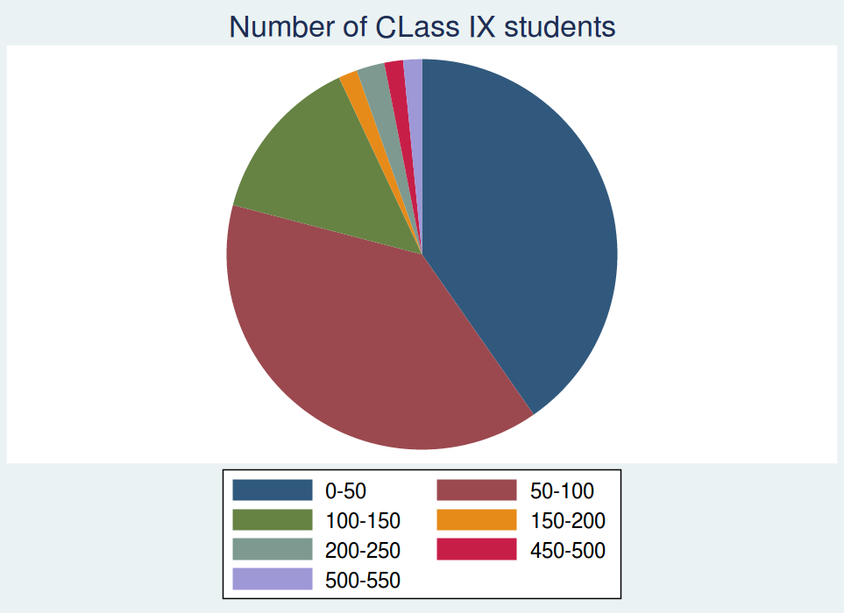
How many hours per week do you teach science to the Class 9?
The average number of houts being taught is 15 and the range varies from 1 hour to a maximum of 315 hours.
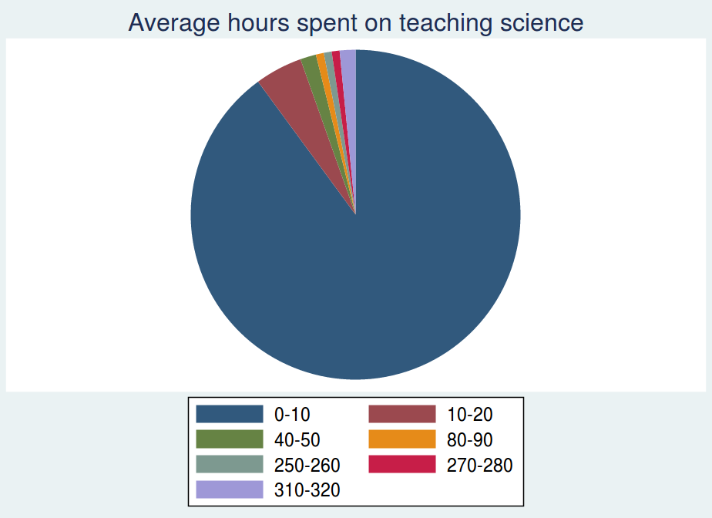

How do you use a textbook(s) in teaching Science to the class 9? | As the primary basis for my lessons | As a supplementary resource | Do not use textbooks in class
 | 54.26 | 44.96 | 0.78

In teaching science to the students in Class 9, how often do you usually ask them to do the following?
 | Never | Some lessons | About half the lessons | Every or almost every lesson)Every or almost every lesson
9.1.Observe natural phenomena and describe what they see | 0.78 | 69.77 | 10.85 | 18.60
9.2.Watch me demonstrate an experiment or investigation | 1.55 | 58.14 | 21.71 | 18.60
9.3.Design or plan experiments or investigations | 7.75 | 51.94 | 15.50 | 24.81
9.4.Conduct experiments or investigations | 5.43 | 55.81 | 17.05 | 21.71
9.5.Work together in small groups on experiments or investigations | 11.63 | 57.36 | 17.83 | 13.18
9.6.Read their textbooks or other resource materials | 2.33 | 31.78 | 15.50 | 50.39
9.7.Have students memorize facts and principles | 1.55 | 34.11 | 14.73 | 49.61
9.8.Use scientific formulae and laws to solve routine problems | 3.88 | 55.04 | 13.95 | 27.13
9.9.Give explanations about something they are studying | 1.55 | 26.36 | 13.18 | 58.91
9.10. Relate what they are learning in science to their daily lives | 0.78 | 29.46 | 13.95 | 55.81

10.In your view, to what extent do the following limit how you teach class 9?
Students | A lot | Some | A little | Not at all | Not applicable
10.1.1.Students with different academic abilities | 41.09 | 46.51 | 10.08 | 2.33
10.1.2.Students come from a wide range of backgrounds (example, economic, language) | 45.74 | 37.21 | 10.85 | 5.43 | 0.78
10.1.3.Students with special needs (e.g., hearing, vision, speech impairment, physical disabilities, mental or emotional/psychological  impairment) | 24.03 | 26.36 | 25.58 | 13.95 | 10.08
10.1.4.Uninterested students | 26.36 | 43.41 | 17.05 | 9.30 | 3.88
10.1.5.Disruptive students | 10.85 | 44.19 | 29.46 | 11.63 | 3.88

Resources | A lot | Some | A little | Not at all | Not applicable
10.2.1.Shortage of computer hardware | 44.19 | 34.11 | 8.53 | 3.88 | 9.30
10.2.2.Shortage of computer software | 44.96 | 35.66 | 6.98 | 5.43 | 6.98
10.2.3.Shortage of support for using computers | 43.41 | 39.53 | 6.20 | 3.88 | 6.98
10.2.4.Shortage of textbooks for student use | 18.60 | 20.93 | 19.38 | 37.98 | 3.10
10.2.5.Shortage of other instructional equipment for students’ use | 24.03 | 45.74 | 17.83 | 10.85 | 1.55
10.2.6.Shortage of equipment for your use in demonstrations and other  exercises | 28.68 | 43.41 | 12.40 | 13.95 | 1.55
10.2.7.Inadequate physical facilities | 28.68 | 48.84 | 13.95 | 7.75 | 0.78
10.2.8.High student/teacher ratio | 27.13 | 30.23 | 22.48 | 14.73 | 5.43

11.By the end of this school year, approximately what percentage of teaching time will you have spent on each of the following science content areas for Class 9? (Write the percent; The total should add to 100%)

Since total for each respondent does not always add upto 100%, the average number of hours is not a reliable analysis. Hence this particular question has been analysed on emphasis given by teachers on a particular in relation to ther topics.

 | Yes | No
12.Do students in Class 9 have computer(s) available to use during their science lessons? | 35.66 | 64.34
13.Do any of the computer(s) have access to the Internet? | 48.53 | 51.47

14.In teaching science to Class 9, how often do you have students use a computer for the following activities?
 | Never | Some lessons | About half the lessons | Every or almost every lesson
14.1. Do scientific procedures or experiments | 35.66 | 51.16 | 6.20 | 6.98
14.2. Study natural phenomena through simulations | 31.78 | 53.49 | 8.53 | 6.20
14.3. Practice skills and procedures | 28.68 | 50.39 | 6.20 | 14.73
14.4. Look up ideas and information | 29.46 | 41.86 | 10.85 | 17.83
14.5. Process and analyze data | 32.56 | 46.51 | 7.75 | 13.18

 | Every or almost every lesson | About half the lessons | Some lessons | Never
15.How often do you usually assign science homework to Class 9? | 89.15 | 6.20 | 4.65

16.How often do you assign the following kinds of science homework to Class 9?
 | Never or almost never | Sometimes | Always or almost always
16.1. Doing problem/question sets | 4.65 | 39.53 | 55.81
16.2. Finding one or more applications of the content covered | 9.30 | 62.02 | 28.68
16.3. Reading from a textbook or supplementary materials | 5.43 | 40.31 | 54.26
16.4. Writing definitions or other short writing assignments | 6.98 | 43.41 | 49.61
16.5. Working on projects | 24.81 | 64.34 | 10.85
16.6. Working on small investigations or gathering data | 24.81 | 66.67 | 8.53
16.7. Preparing reports | 25.58 | 63.57 | 10.85

17.How often do you do the following with the science homework assignments for the Class 9?
 | Never or almost never | Sometimes | Always or almost always
17.1. Monitor whether or not the homework was completed | 8.53 | 20.93 | 70.54
17.2. Correct assignments and then give feedback to students | 5.43 | 22.48 | 72.09
17.3. Have students correct their own homework in class | 13.95 | 48.06 | 37.98
17.4. Use the homework as a basis for class discussion | 13.95 | 53.49 | 32.56
17.5. Use the homework to contribute towards students’ grades or marks | 27.91 | 41.86 | 30.23

18.What item formats do you typically use in your science tests or examinations?
 | Only constructed-response | Mostly constructed-response | About half constructed-response and half objective(e.g., multiple-choice) | Mostly objective | Only objective
 | 4.65 | 17.05 | 71.32 | 6.98

19.How often do you include the following types of questions in your science tests or examinations?
 | Never or almost never | Sometimes | Always or almost always
19.1. Questions based on knowing facts and concepts | 6.20 | 58.14 | 35.66
19.2. Questions based on the application of knowledge and understanding | 5.43 | 43.41 | 51.16
19.3. Questions involving developing hypotheses and designing scientific investigations | 10.08 | 55.81 | 34.11
19.4. Questions requiring explanations or justifications | 7.75 | 55.04 | 37.21

20. How strongly do you feel the need to have the following included as part of the Science Teacher Professional Development Course?
 | I strongly need training in this | I need some training in this | I don't need training in this
20.1. Subject understanding | 17.83 | 74.42 | 7.75
20.2. Pedagogical tools and techniques | 19.38 | 74.42 | 6.20
20.3. Integration of technology in teaching | 28.68 | 65.12 | 6.20
20.4. Student Assessments | 11.63 | 69.77 | 18.60

21.I would like teacher professional development to be offered in the form of:
 | Yes | No
21.1. Face to face lectures | 82.95 | 17.05
21.2. Computer based training sessions | 94.57 | 5.43
21.3. Interactions with other teachers (peer learning) | 97.67 | 2.33
21.4. Referring to books, magazines | 94.57 | 5.43
21.5. Hands-on activities for teachers | 96.12 | 3.88

