Tool | A few descriptive statictics from Maths Teachers' data
Data Dump | 6th September 2016
Preliminary analysis done by | Arundhati

2. I believe that

 | Strongly agree | Agree | No opinion | Disagree | Strongly Disagree
Students who find math difficult do not have the ability to do mathematics | 29.46 | 48.84 | 2.33 | 16.28 | 3.10
2.2. Students who solve problems quickly are good at maths | 40.31 | 42.64 | 0.78 | 13.18 | 3.10
2.3. Students who stick to the procedures told in class do well in maths | 3.10 | 26.36 | 6.20 | 56.59 | 7.75
2.4. Geometry does not have any practical use for our students | 51.94 | 44.96 | 1.55 | 1.55
2.5. For some reason boys are better at doing mathematics than girls. | 43.41 | 53.49 | 3.10
2.6. Games and activities are suitable for primary school maths, not for high  school maths | 51.16 | 48.06 | 0.78

3. In the Mathematics classroom that I teach:
 | Strongly agree | Agree | No opinion | Disagree | Strongly Disagree
3.1. I have no time to do additional activities, because I have to cover all  content in the textbook. | 5.43 | 13.95 | 6.20 | 59.69 | 14.73
3.2. Students need to know only the standard procedures because alternative procedures confuse them | 26.36 | 60.47 | 1.55 | 11.63
3.3. Connecting maths with out-of-school contexts is not useful | 13.18 | 48.84 | 4.65 | 31.78 | 1.55
3.4. Boys answer questions more frequently than girls |  | 6.20 | 6.20 | 68.22 | 19.38
3.5. When students make mistakes, the best remedy is to give them repeated practice of similar problems. | 0.78 | 10.85 | 7.75 | 59.69 | 20.93
3.6. Only one concept is taught at a time because discussing many concepts together confuses students. | 3.88 | 27.91 | 17.05 | 44.96 | 6.20

3. In the Mathematics classroom that I teach:
 | Strongly agree | Agree | No opinion | Disagree | Strongly Disagree
3.1. I have no time to do additional activities, because I have to cover all  content in the textbook. | 11.63 | 35.66 | 7.75 | 36.43 | 8.53
3.2. Students need to know only the standard procedures because alternative procedures confuse them | 2.33 | 24.03 | 10.85 | 54.26 | 8.53
3.3. Connecting maths with out-of-school contexts is not useful | 1.55 | 9.30 | 10.08 | 63.57 | 15.50
3.4. Boys answer questions more frequently than girls | 1.55 | 8.53 | 6.20 | 67.44 | 16.28
3.5. When students make mistakes, the best remedy is to give them repeated practice of similar problems. | 31.01 | 55.81 | 2.33 | 10.85
3.6. Only one concept is taught at a time because discussing many concepts together confuses students. | 15.50 | 55.04 | 3.10 | 25.58 | 0.78

In the Mathematics classroom:
 | Always | Frequently | Sometimes | Never
4.1. I solve one/two problems on the board & ask students to solve the rest of the textbook exercises in their notebooks | 23.26 | 19.38 | 39.53 | 17.83
4.2. I do learning activities (games, puzzles) with students | 16.28 | 9.30 | 68.22 | 6.20
4.3. I do activities that involve group work that allow students to see, share and discuss their class work/maths problem solutions with each other | 13.18 | 20.16 | 58.14 | 8.53
4.4. I maintain silence/ discipline because students must concentrate and individually do maths | 52.71 | 24.81 | 20.16 | 2.33
4.5. I encourage students to come up with their own ideas about how to solve problems. | 58.14 | 27.91 | 13.18 | 0.78

How well prepared do you feel you are to teach the following topics?

 | Very well prepared | Somewhat prepared | Not well prepared | Not applicable
Computing, estimating or approximating with whole numbers | 54.26 | 40.31 | 3.10 | 2.33
Representing decimals and fractions using words, numbers, or models | 55.81 | 36.43 | 6.20 | 1.55
Computing with fractions and decimals | 62.79 | 35.66 | 1.55
Representing, comparing, ordering, and computing with integers | 59.69 | 35.66 | 4.65
Problem solving involving percents and proportions | 62.02 | 34.11 | 2.33 | 1.55
Numeric, algebraic, and geometric patterns or sequences  (extension, missing terms, generalization of patterns) | 60.47 | 35.66 | 2.33 | 1.55
Simplifying and evaluating the algebraic expressions | 71.88 | 25.00 | 2.34 | 0.78
Simple linear equations and inequalities, and simultaneous (two variables) equations | 71.88 | 24.22 | 2.34 | 1.56
Equivalent representations of functions as ordered pairs, tables, graphs, words, or equations | 59.38 | 36.72 | 2.34 | 1.56
Geometric properties of angles and geometric shapes (triangles, quadrilaterals, and other common polygons) | 64.06 | 32.03 | 3.12 | 0.78
Congruent figures and similar triangles | 58.59 | 39.84 | 0.78 | 0.78
Relationship between three–dimensional shapes and their two-dimensional representation | 44.53 | 47.66 | 4.69 | 3.12
Using appropriate measurement formulas for perimeters,  circumferences, areas of circles, surface areas and volumes | 67.97 | 28.91 | 0.78 | 2.34
Cartesian plane - ordered pairs, equations, intercepts, intersections, and gradient Translation, reflection, and rotation | 40.62 | 46.09 | 6.25 | 7.03
Reading and displaying data using tables, pictographs, bar graphs, pie charts and line graphs | 59.38 | 33.59 | 5.47 | 1.56
Interpreting data sets (e.g., draw conclusions, make predictions, and estimate values between and beyond given data points) | 50.00 | 40.62 | 3.91 | 5.47
Judging, predicting, and determining the chances of possible outcomes | 46.88 | 44.53 | 5.47 | 3.12

How often do you have the following types of interactions with other teachers?
 | Daily or almost daily | 1-3 times per week | 2 or 3 times per month | (almost) Never
6.1. Discussions about how to teach a particular concept | 22.66 | 31.25 | 36.72 | 9.38
6.2. Working on preparing lesson plans | 43.75 | 23.44 | 24.22 | 8.59
6.3. Visits to another teacher’s classroom to observe his/her teaching | 4.69 | 9.38 | 19.53 | 66.41
6.4. Informal observations of my classroom by another teacher | 3.12 | 6.25 | 32.03 | 58.59

In the past two years, have you participated in professional development in any of the following?
 | yes | No
7.1. Mathematics content | 62.50 | 37.50
7.2. Mathematics pedagogy/instruction | 56.25 | 43.75
7.3. Mathematics curriculum | 53.91 | 46.09
7.4. Integrating information technology into mathematics | 35.16 | 64.84
7.5. Improving students’ critical thinking or problem solving skills | 61.72 | 38.28
7.6. Mathematics assessment | 62.50 | 37.50

8. How many students are in class 9 that you teach?

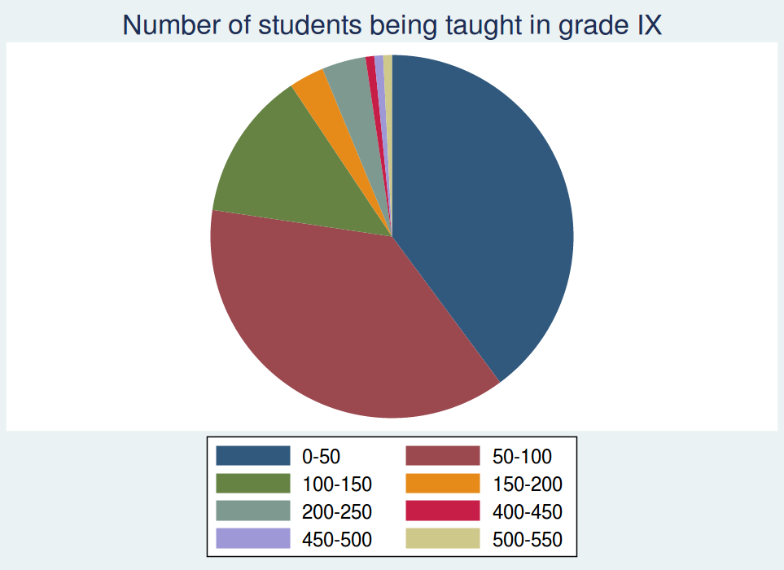

9. How many hours per week do you teach mathematics to the Class 9?

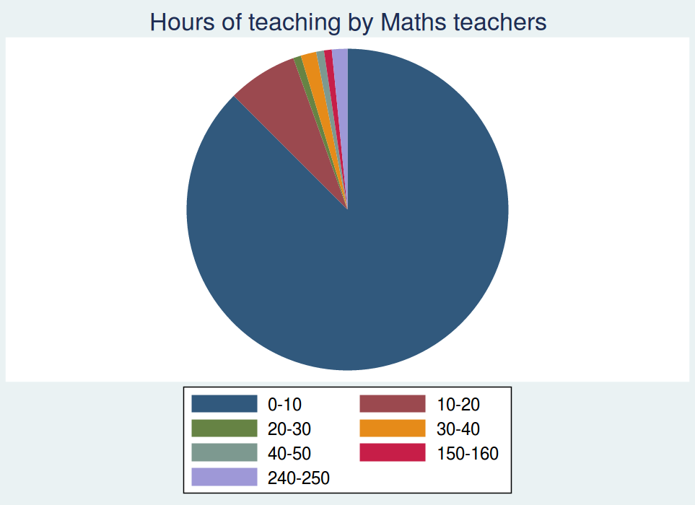

10. How do you use a textbook(s) in teaching mathematics to the class 9?
As the primary basis for my lessons | As a supplementary resource | Do not use
71.88 | 27.34 | 0.78

12. In teaching mathematics to the students in the class 9, how often do you usually ask them to do the following?
 | Never | Some lessons | About half the lessons | (Almost) every lesson
12.1. Practice adding, subtracting, multiplying, and dividing without using a calculator | 17.97 | 16.41 | 3.91 | 61.72
12.2.Work on fractions and decimals | 5.47 | 57.81 | 11.72 | 25.00
12.3. Use knowledge of the properties of shapes, lines and angles to solve problems | 2.34 | 71.88 | 14.06 | 11.72
12.4. Interpret data in tables, charts or graphs | 5.47 | 78.91 | 3.91 | 11.72
12.5.Write equations and functions to represent relationships | 3.91 | 75.00 | 7.81 | 13.28
12.6. Memorize formulas and procedures | 1.56 | 35.16 | 7.81 | 55.47
12.7.Apply facts, concepts and procedures to solve routine problems | 2.34 | 35.94 | 10.94 | 50.78
12.8. Explain their answers | 2.34 | 39.06 | 9.38 | 49.22
12.9.Relate what they are learning in mathematics to their daily lives | 2.34 | 40.62 | 14.84 | 42.19
12.10. Decide on their own procedures for solving complex problems | 8.59 | 55.47 | 8.59 | 27.34
12.11. Work on problems for which there is no immediately obvious method of solution | 14.06 | 60.94 | 7.03 | 17.97
12.12. Work together in small groups | 11.72 | 62.50 | 8.59 | 17.19

 | Yes | No
13.Do students in Class 9 have computer(s) available to use during their Math lessons? | 22.66 | 77.34
14.Do any of the computer(s) have access to the Internet? | 31.82 | 68.18

15. In teaching Math to Class 9, how often do you have students use a computer for the following activities?
 | Never | Some lessons | About half the lessons | Every or almost every lesson
15.1. Practice solving mathematics problems | 66.41 | 20.31 | 3.12 | 10.16
15.2. Play mathematics based games | 68.75 | 28.91 | 0.78 | 1.56
15.3. Learn new mathematical concepts | 57.03 | 28.91 | 3.12 | 10.94
15.4. For mathematical calculations | 65.62 | 20.31 | 4.69 | 9.38

16. In your view, to what extent do the following condition limit how you teach Math for class 9?
Students | A lot | Some | A Little | Not at all | No applicable
16.1.1. Students with different academic abilities | 37.50 | 44.53 | 14.84 | 3.12
16.1.2. Students come from a wide range of backgrounds (example economic, language). | 39.84 | 38.28 | 17.19 | 4.69
16.1.3. Students with special needs (e.g., hearing, vision, speech impairment, physical disabilities, mental or emotional/psychological impairment) | 19.53 | 28.91 | 39.06 | 7.03 | 5.47
16.1.4. Uninterested students | 21.88 | 36.72 | 22.66 | 7.81 | 10.94
16.1.5. Disruptive students | 10.94 | 28.12 | 32.81 | 17.19 | 10.94

16.2. Resources | A lot | Some | A Little | Not at all | No applicable
16.2.1. Shortage of computer hardware | 42.19 | 23.44 | 11.72 | 7.03 | 15.62
16.2.2. Shortage of computer software | 40.62 | 25.00 | 11.72 | 6.25 | 16.41
16.2.3.Shortage of support for using computers | 47.66 | 22.66 | 10.16 | 8.59 | 10.94
16.2.4. Shortage of textbooks for student use | 11.72 | 19.53 | 11.72 | 49.22 | 7.81
16.2.5. Shortage of other instructional equipment for students’ use | 18.75 | 41.41 | 23.44 | 12.50 | 3.91
16.2.6. Shortage of equipment for your use in demonstrations and other exercises | 19.53 | 41.41 | 26.56 | 9.38 | 3.12
16.2.7. Inadequate physical facilities | 23.44 | 40.62 | 26.56 | 5.47 | 3.91
16.2.8. High student/teacher ratio | 28.12 | 32.81 | 20.31 | 14.06 | 4.69

How often do you usually assign mathematics homework to the Class 9?
 | Every or almost every lesson; | About half the lessons | Some lessons | Never
 | 89.76 | 3.15 | 7.09

19. When you assign mathematics homework to class 9 students, about how many minutes do you usually assign? (Consider the time it would take an average student in your class.)
 | Less than 15 minutes | 15-30 minutes | 31-60 minutes | 61-90 minutes | More than 90 minutes
 | 31.50 | 40.94 | 22.05 | 4.72 | 0.79

20. How often do you assign the following kinds of mathematics homework to class 9?
 | Never or almost never | Sometimes | Always or almost always
20.1. Doing problem/question sets |  | 40.94 | 59.06
20.2. Gathering data and reporting | 15.75 | 77.95 | 6.30
20.3. Finding one or more practical applications of the content covered | 11.81 | 76.38 | 11.81

21. How often do you do the following with the mathematics homework assignments for the Class 9?
 | Never or almost never | Sometimes | Always or almost always
21.1. Monitor whether or not the homework was completed | 0.79 | 24.41 | 74.80
21.2.Correct assignments and then give feedback to students | 1.57 | 25.98 | 72.44
21.3. Have students correct their own homework in class | 11.02 | 50.39 | 38.58
21.4. Use the homework as a basis for class discussion | 11.02 | 52.76 | 36.22
21.5. Use the homework to contribute towards students’ grades or marks | 22.83 | 51.97 | 25.20

22.How much emphasis do you place on the following sources to monitor students’ progress in mathematics?
 | No emphasis | Little emphasis | Some emphasis | Major emphasis
22.1.Classroom tests (for example, teacher made or textbook tests) | 0.79 | 4.72 | 38.58 | 55.91
22.2. National or regional achievement tests | 11.02 | 22.05 | 41.73 | 25.20
22.3. Your professional judgment | 3.94 | 11.02 | 37.01 | 48.03

23. How often do you include the following types of questions in your mathematics tests or examinations?
 | Never or almost never | Sometimes | Always or almost always
23.1. Questions based on recall of facts and procedures | 3.15 | 61.42 | 35.43
23.2. Questions involving application of mathematical procedures | 3.15 | 45.67 | 51.18
23.3. Questions involving searching for patterns and relationships | 7.87 | 63.78 | 28.35
23.4. Questions requiring explanations or justifications | 4.72 | 62.20 | 33.07

How strongly do you feel the need to have the following included as part of the Math Teacher Professional Development Course to contain?
 | I strongly need training in this | I need some training in this | I don't need training in this
24.1. Subject understanding | 14.17 | 65.35 | 20.47
24.2. Pedagogical tools and techniques | 16.54 | 71.65 | 11.81
24.3. Integration of technology in teaching | 37.01 | 57.48 | 5.51
24.4. Student Assessments | 11.81 | 64.57 | 23.62

I would like teacher professional development to be offered in the form of:
 | Yes | No
25.1. Face to face lectures | 78.74 | 21.26
25.2.Computer based training sessions | 85.04 | 14.96
25.3. Interactions with other teachers (peer learning) | 93.70 | 6.30
25.4. Referring to books, magazines | 88.19 | 11.81
25.5. Hands-on activities for teachers | 95.28 | 4.72

26. How would you characterize each of the following within your school?
 | Very low | low | Medium | high | Very high
26.1.Teachers’ job satisfaction | 3.15 | 4.72 | 36.22 | 46.46 | 9.45
26.2.Teachers’ understanding of the school’s curricular goals | 2.36 | 3.94 | 31.50 | 55.12 | 7.09
26.3.Teachers’ degree of success in implementing the school’s curriculum | 1.57 | 2.36 | 41.73 | 46.46 | 7.87
26.4.Teachers’ expectations for student achievement | 0.79 | 2.36 | 30.71 | 51.97 | 14.17
26.5.Parental support for student achievement | 18.11 | 27.56 | 26.77 | 19.69 | 7.87
26.6.Parental involvement in school activities | 26.77 | 33.07 | 22.83 | 13.39 | 3.94
26.7.Students’ regard for school property | 7.87 | 18.11 | 40.94 | 24.41 | 8.66
26.8.Students’ desire to do well in school | 3.94 | 10.24 | 38.58 | 36.22 | 11.02

