Title: Building Fractions

Definition:

Fraction is defined a part of a whole.

Important Questions:

What is a common fraction made up of?
How do we determine the numerator of the fraction?
How do we determine the denominator of the fraction?

Instructions:

In this activity, the above questions are investigated. Complete this document by filling in data tables and writing complete responses. This investigation has three phases: Exploration, Explanation and Application. Work between this document and the simulation (sim).

Click on the image below to lead you to the simulation!
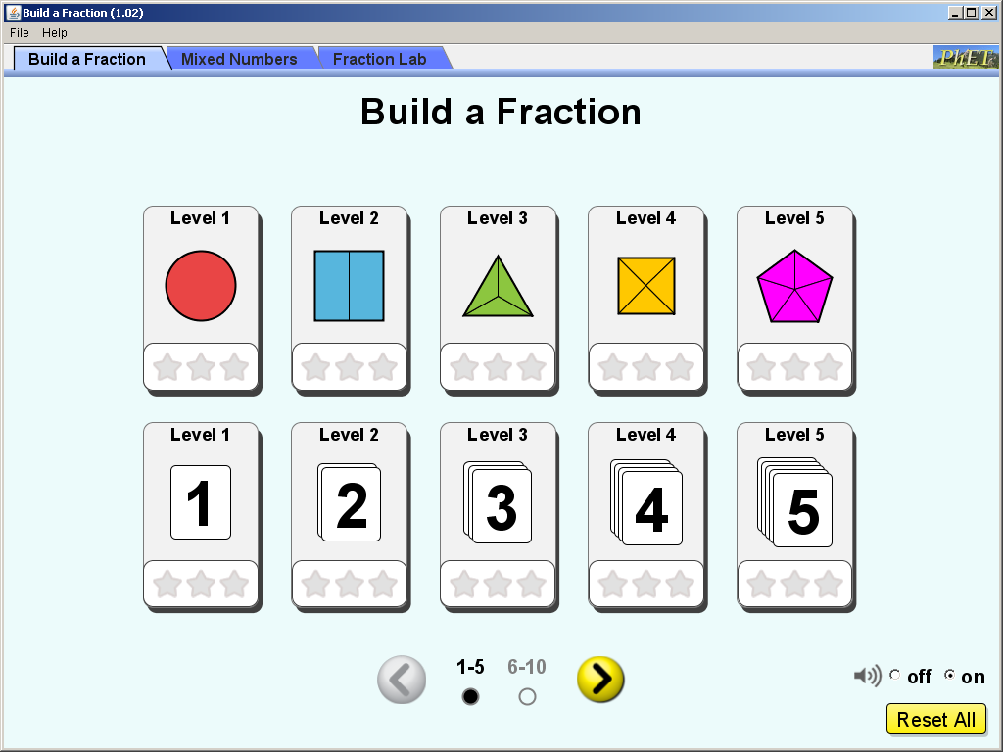

Exploration Phase (5-7 minutes)

1.Briefly explore the sim. Click each tab..

2. Place various fractions on each tab and place in the correct box with the fraction..

3. Try different tabs in the box.

5. Now please go to the ‘Build a Fraction’ Tab.

Questions

Level 2 (with the blue rectangle) How many parts did you use? (denominator)
How many colored pieces did you choose? (Numerator)

This is how you go back to the levels. Click the top left box as shown in the picture below
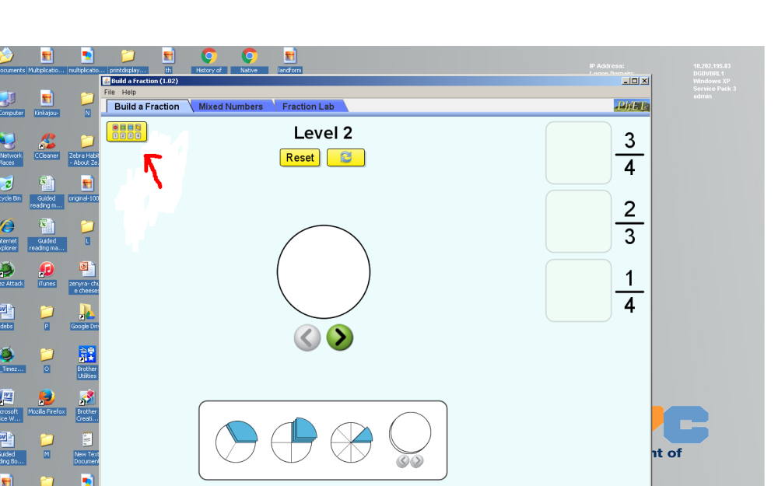
Level 5 (with the purple pentagon) Show me two different ways to make 3/6 Screen shot both and place it below.

How many parts did you use? (Denominator)
How many colored pieces did you choose for both? (Numerator)

On the Home page : Level 3 (Bottom Row)
How do you know which number is the numerator?
How do you know which number is the denominator?

Explanation Phase:
This Phase has an investigative goal.

Aim: I can recognize and create mixed fractions.

Click on the “Mixed Fraction” tab. This screen appears:
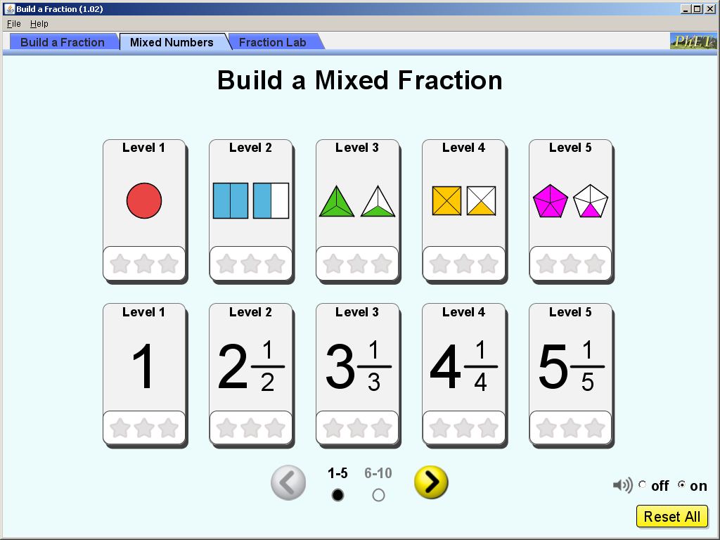

Use these concepts:

You can make an extra circle if you needed by clicking the green + sign
You can always reset if you need.

Below are five different levels and mixed fraction. Complete each fraction on the correct level and fill in the blanks.

Level  BOLD = Top Row  Regular = Bottom Rows | Mixed Numbers | Show your work of each  (Screenshot when done)
2 (Blue Rectangle)
4 (Yellow Squares)
6 (Yellow Stars)
8 ( Purple Stars)
Now you will do the bottom levels but you will be making the fraction based on the picture. Therefore, when you complete the level screenshot your work for each level. It may require for you to put the fraction in simplest form. Be Careful. Enjoy!
Level 3
Level 5
Level 7
Level 9
Level 10

Challenge yourself on levels 7-10 top and bottom levels.

What’s the difference between the top levels and bottom levels? What was the hardest for you?

Application Phase: Fraction Lab:
(10 minutes)

Click the “Fraction Lab” tab. The screen below appears.
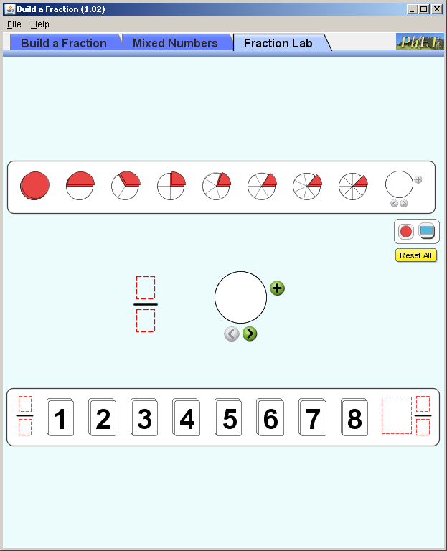

I will give you the mixed number as you see on your data table. Please make the fraction and screenshot what it looks like.

NUMERATOR/DENOMINATOR
EXAMPLE: 5/8
5 = ________________
8 =________________
MAKE SURE you have the Red Circles first::

⅔
Numerator: _____
Denominator: ___
5/4
Numerator: _____
Denominator: ___
7/2
Numerator: _____
Denominator: ___
2/7
Numerator: _____
Denominator: ___
Insert your own
Numerator: _____
Denominator: ___

Make sure you have the BLUE Rectangles: Please click it in the upper right corner. Drag a rectangle on the upper right corner.

1 ½
Numerator: _____
Denominator: ___
2 ⅕
Numerator: _____
Denominator: ___
8/5
Numerator: _____
Denominator: ___
Insert your own Numerator: _____
Denominator: ___

Finished: Congratulations. Way to go!

