**Name:____________________________________ Block: _______**

|  |  |  |
| --- | --- | --- |
| **Picture 3** | **Computer Simulation: Field & Potential**  In this activity you will use the Simulation: *Charges and Fields* to develop your understanding of the relationship between electric fields and electric potential. | **Macintosh HD:Users:aubryfarenholtz:Desktop:Screen Shot 2014-04-02 at 8.05.41 AM.png** |

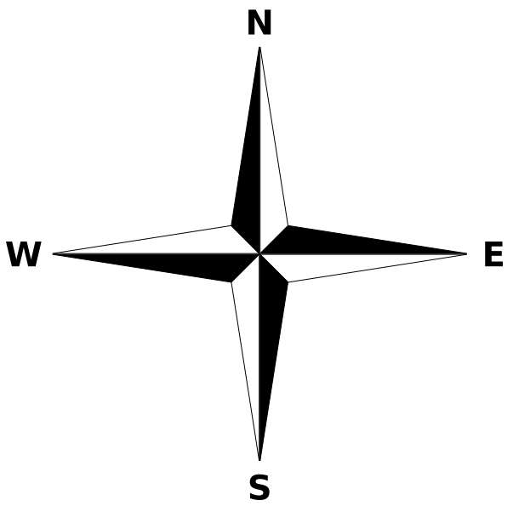

**Part I:** **Electric Field (CORE)**

Open the *PHET* simulation “Charges and Fields”. Add positive and negative charges as shown in the diagram below. Draw appropriate electric field lines around and in between the three charges.



1. Where is the electric field the largest? (label the point **#1** in your diagram)
2. Where is the electric field equal to zero? (label the point **#2** in your diagram)
3. Describe what would happen to an electron placed at location **#2**.

1. What would happen to an electron placed in the location shown below? Explain…



1. What would happen to a proton placed in the location shown below? Explain…



**Part II:** **Electric Potential (CORE)**

**1.** *Clear All* in the simulation. Add a positive and negative charge as shown in the diagram below. Plot equipotential lines in 10 V increments.

Note: For this exercise the potential do not need to be precise; the patterns will still be evident if you are within +/- 0.5 V

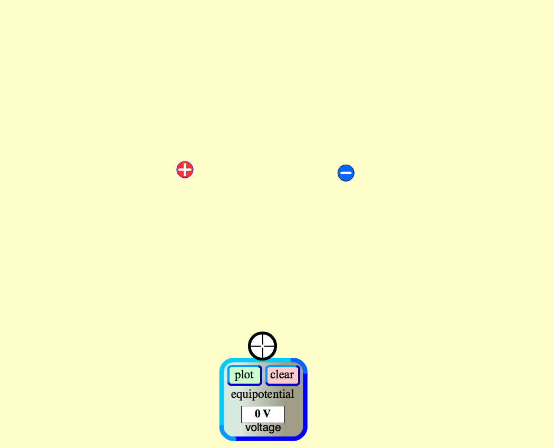

Are the equipotential lines evenly spaced (this would suggest a linear relationship) or exponential?

_________________________________________________________________________

**2.** Create a simulation of two parallel charged plates, similar to the one shown below.

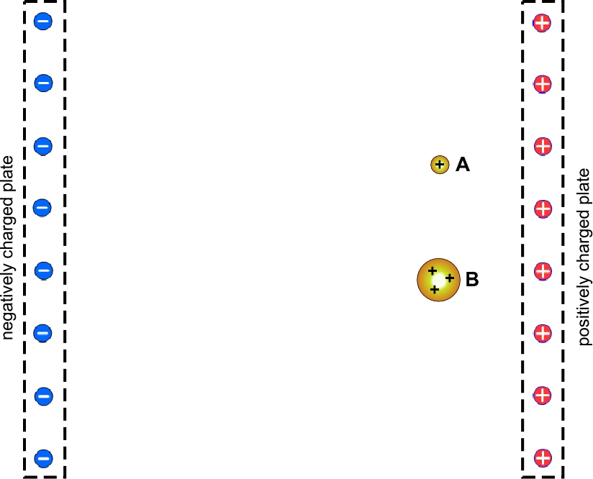

1. Draw the electric field lines in between the two plates (use dotted lines). What do you notice about the field lines in the central region between the plates?

**b)** Draw the equipotential lines for potentials in 10 V increments, from -70 V to plus 70 V. (use solid lines). What do you notice about the lines of equipotential compared to lines of equipotential?

**c)** Two positively charged particles A and B, are placed in between the plates as shown in the above diagram. Particle B has three times the charge and five times the mass of particle A. Compare the motions (path and acceleration) of the two charges

**d)** Calculate the final velocity of each particle when they reach the negative plate, assuming they both started from rest. (Note that each group may have a slightly different solution depending where the equipotential lines were drawn).

 



**Part III:** **Electric Potential (MASTERY)**

**1.** Use the simulation to create the pattern of equipotential lines shown below.

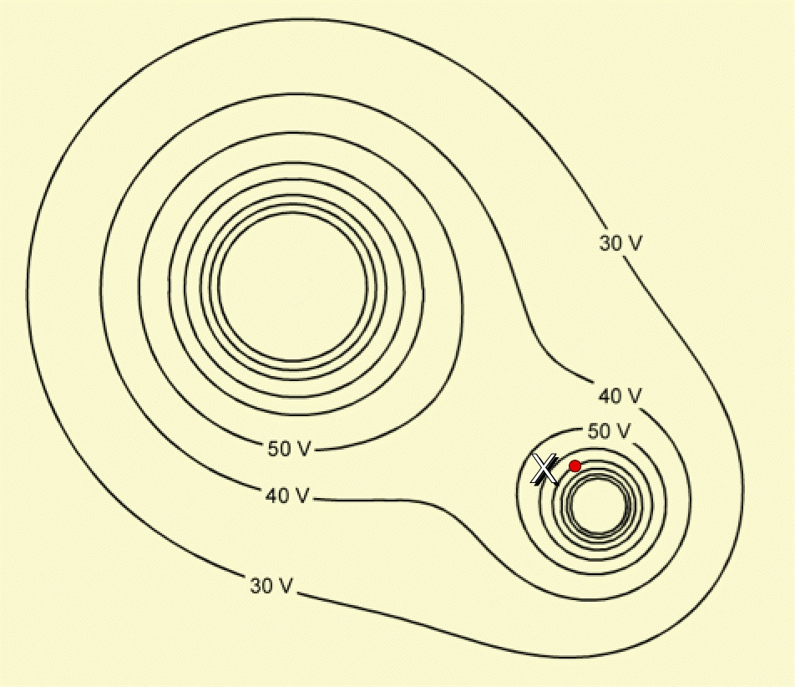

1. Indicate the polarity and the number of charges in each location.
2. Draw the *electric field* on the two 50 V equipotential lines. (Focus on the direction and the relative number of field lines)
3. Describe what the electric field lines represent.

1. Label a location in the diagram where an electron (**e**) would have the maximum potential energy. Repeat the process for a proton (**p**).
2. Predict the path that a proton would travel if released from the dot at location **X**; use a dotted line and draw the path of the proton in the diagram.
3. Calculate the maximum velocity and kinetic energy of the proton assuming it started from rest; express its final energy in electron-volts (eV)



1. Explain why you would not be able to calculate the final velocity of the electron (given the information provided in the problem).

**Part III:** **Electric Potential (SCHOLARSHIP)**

1. Given the charge diagram shown below, draw the shape of an equipotential line of

0 V *without the simulation!*

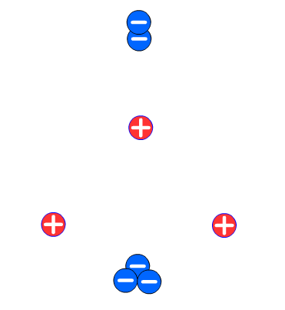

Now verify your solution using the simulation…

**2.** Choose a location anywhere along the 0 V equipotential line where a released charged particle would follow a curved path – label that location in the diagram. Use dotted lines to sketch the path an electron **(e)** and proton **(p)** would follow if it were to be released at that point.