Plinko – What are the chances?

PRE-PLANNING | PRIOR KNOWLEDGE
 | - Students should understand some basic probability terms, such as if the probability is zero, there is no chance of an action occurring, while if the probability is 100%, it definitely will happen.
 | LEARNING GOALS
- Students will conceptualize the ideas of randomness, and distribution.
- Students will be able to describe the pattern formed by the data, as well as describe any outliers of that data.
- Students will be able to make predictions about more and less likely events
- Students will be able to calculate probabilities
 | Common Core Standards | Common Core Practices
 | CCSS.Math.Content.6.SP.A.2  Understand that a set of data collected to answer a statistical question has a distribution which can be described by its center, spread, and overall shape.  CCSS.Math.Content.6.SP.B.4  Display numerical data in plots on a number line, including dot plots, histograms, and box plots.  CCSS.Math.Content.6.SP.B.5.c  Giving quantitative measures of center (median and/or mean) and variability (interquartile range and/or mean absolute deviation), as well as describing any overall pattern and any striking deviations from the overall pattern with reference to the context in which the data were gathered. | 2. Reason abstractly and quantitatively  7. Look for and make use of structure
 | MATERIALS
- PhET Plinko simulation: https://phet.colorado.edu/en/simulation/plinko-probability
- Laptop/Chromebook/tablet for each student or pair
- Seating chart that allows for occasional pairings of students.
LESSON CYCLE | Develop a context 8 minutes
Ask students who has been played Plinko before. It’s likely that very few students have played it or seen it played, so you will want to help students to understand the game. Plinko is probably the most well-known game on The Price is Right. Bob Barker said the name, “Plinko” came from the Plinking sound of the coins falling. You can show the students this video that shows someone winning at Plinko.
https://www.youtube.com/watch?v=E7DKxe_m1AM
 | Explore the simulation 5 minutes
Ask the students to access the PhET Plinko Simulation: https://phet.colorado.edu/en/simulation/plinko-probability
Allow students 5 minutes to explore the sim. Ask students, as you walk around:
Where is the ball more likely to fall?
Where is it less likely to fall?
As a whole class, provide students with time to share what they learned about the sim, especially pointing out features of the sim’s controls, and making connections between the buckets of balls and the bar graph.
 | Making Sense of Plinko 20-40 minutes
Pass out the worksheet to the students. Have the students work independently or in pairs to answer the questions.
Circulate the room to be available for student questions and to ask probing/pushing questions. If a student is struggling with the task, it can help to probe for more information.
Ask students:
- What have you tried?
- What do you notice happens at each pin? (sometimes right and sometimes left)
- How can we systematically show all the possibilities? (allow students to come up with their own strategies)
 | Discussion 10 minutes
Bring the class together for a whole-class discussion.
- Remind students to close their laptops or turn around so that the sim does not distract them from listening.
- Use an established teaching strategy such as popcorn discussion (one student answers, calls on the next student to talk), think-pair-share (pose question, allow time to think, turn and talk to partner), or group discussions (print out questions and have groups talk to each other and write down consensus to share aloud with class). Sample questions include:
  - What happens when the ball hits a pin?
  - What determines if it goes left or right?
  - How many paths did you find to bin 0? Bin 5?
  - On a board with five rows, why are the number of paths to bin 0 and bin 5 the same?
  - If they are the same, what other bins must have matching probabilities?
  - What are the chances that the balls will land in one of the 6 bins? How do you know?
  - How did you come up with your prediction? (push for multiple ways of seeing)
 | Wrap Up 5 minutes
Bring the class together for a final whole-class discussion.
- Remind students to close their laptops or turn around so that the sim does not distract them from listening.
- Use an established teaching strategy such as popcorn discussion (one student answers, calls on the next student to talk), think-pair-share (pose question, allow time to think, turn and talk to partner), or group discussions (print out questions and have groups talk to each other and write down consensus to share aloud with class). Sample questions include:
- For the five row Plinko Game…
- Is the ball more likely to fall in Bin 2 or 3? (equally likely)
- How could we extend our pattern if the Plinko machine now had 6 rows?
- Why is a ball more likely to fall toward the middle compared to the edges? (NOT just because the ball is dropped in the center, but because there are more paths that could lead to the center bin than the edge bins.)

Name: Class: Date:

Plinko Probability
Start on the INTRO tab.

- Pretend you are playing Plinko on The Price is Right. How would you choose which bin you think the ball would land in?

- Send 10 balls through the Pinko Machine. Draw where they land. Did they all land where you expected?

- Clear the screen and send another 10 through the machine. Again, draw where they land. Was the picture identical to the one above? Why or why not?

- Now try 100 balls. Erase and retry several times. What do you notice? Sketch the pattern you see.

- Where is a ball more likely to land? Less likely?

- How might you go about figuring out the probability of landing in a particular bin?

- When I played Plinko, my ball landed in the bin shown below. Draw all of the possible paths to land in that bin. (You can see an example of what I mean by “paths” by clicking on the lab screen, and then on Path.)
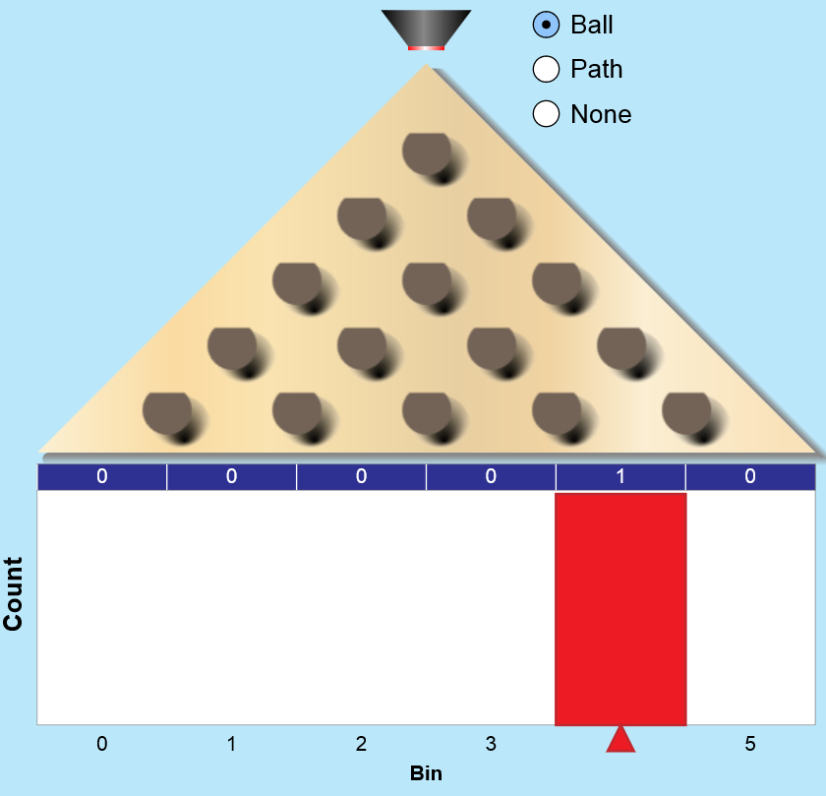
How many paths did you find?

- Try this again. Look at the next picture and draw the possible paths to get to this bin.
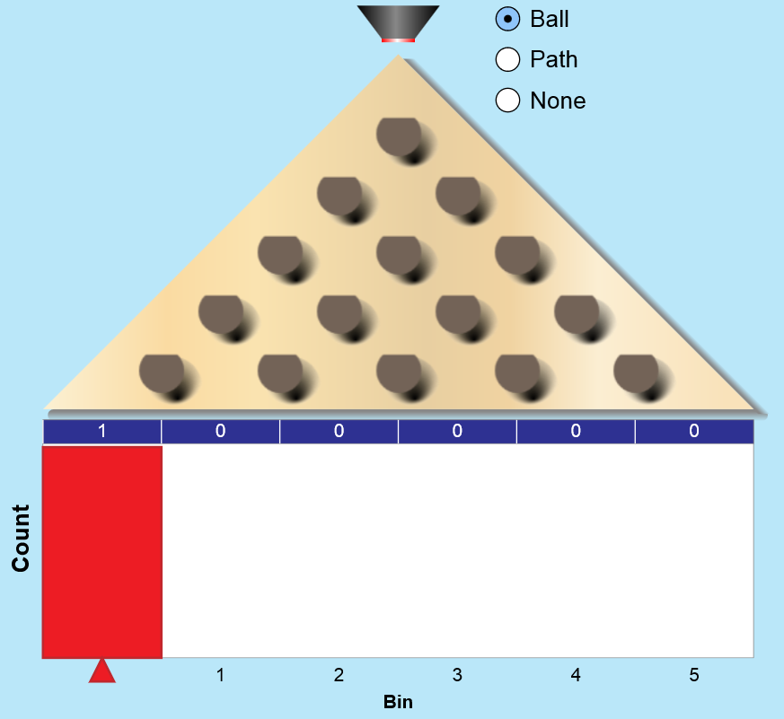

How many paths did you find?

- Sam just noticed that his worksheet was copied backwards. So instead of drawing lines to bin 0, he drew the paths to bin 5. Will he have to start again? Why or why not?

- For each pin, what is the probability that the ball will move to the right? What is the probability that it will move to the left?

- Talk to your partner about what you learned. Is it equally possible to land in all bins? If not, how would we determine the probability?

- Work with your partner to come up with your prediction for the probability that a ball will land in bins 0 through 5.

- Once you have your prediction, send a continuous number of balls through the Pinko machine. You can click the button to see the actual probabilities. How close were your predictions?

Name: Class: Date:

Plinko Probability – Answer Key
Start on the INTRO tab.

- Pretend you are playing Plinko on The Price is Right. How would you choose which bin you think the ball would land in?
Answers will vary. Expect that students will have a variety of strategies that they may suggest.

- Send 10 balls through the Pinko Machine. Draw where they land. Did they all land where you expected?
Answers will vary. With only 10 balls, they will see a
random distribution

- Clear the screen and send another 10 through the machine. Again, draw where they land. Was the picture identical to the one above? Why or why not?
It is not identical since the balls fall in different patterns

- Now try 100 balls. Erase and retry several times. What do you notice? Sketch the pattern you see.
Students will see a normal distribution

- Where is a ball more likely to land? Less likely?
Balls are more likely to fall in the middle, and less likely the further you are from the middle
- How might you go about figuring out the probability of landing in a particular bin?
Answers will vary – students will likely have a variety of strategies.

- When I played Plinko, my ball landed in the bin shown below. Draw all of the possible paths to land in that bin. (You can see an example of what I mean by “paths” by clicking on the lab screen, and then on Path.)
How many paths did you find?
4 paths

- Try this again. Look at the next picture and draw the possible paths to get to this bin.

How many paths did you find?
1 path

- Sam just noticed that his worksheet was copied backwards. So instead of drawing lines to bin 0, he drew the paths to bin 5. Will he have to start again? Why or why not?

No, there is still only one path. There is symmetry between the two sides

- For each pin, what is the probability that the ball will move to the right? What is the probability that it will move to the left?
There is a 50% chance that it will move either direction

- Talk to your partner about what you learned. Is it equally possible to land in all bins? If not, how would we determine the probability?
Answers may vary. Students should recognize that more paths makes it more likely.

- Work with your partner to come up with your prediction for the probability that a ball will land in bins 0 through 5.
Answers will vary. Students should have reasonable estimates where the chances of the ball landing in the center should be higher than landing on the edges. The total percent should equal 100%.
- Once you have your prediction, send a continuous number of balls through the Pinko machine. You can click the button to see the actual probabilities. How close were your predictions?
Answers will vary based on their prediction.

