Student Worksheet
Forces and Motion: Learning Activity Packet – Level I

An online lab that incorporates data collection, data analysis, graphing and differentiated instruction.

Name(s) : ________________________________________ Section: _________________________

________________________________________ Date: ___________________________

Level I – Minimum Difficulty

Discussion: With your lab partner, discuss how you would define force. Record your definition of force in the space below.
____________________________________________________________________________________________________________________________________________________________________________________

Lab Instructions:
- Click on the following link or copy/paste it in your browser.
http://phet.colorado.edu/en/simulation/forces-and-motion-basics
- Run the program titled Forces and Motion: Basics
- Select the Tug of War tab and begin.
Figure-1
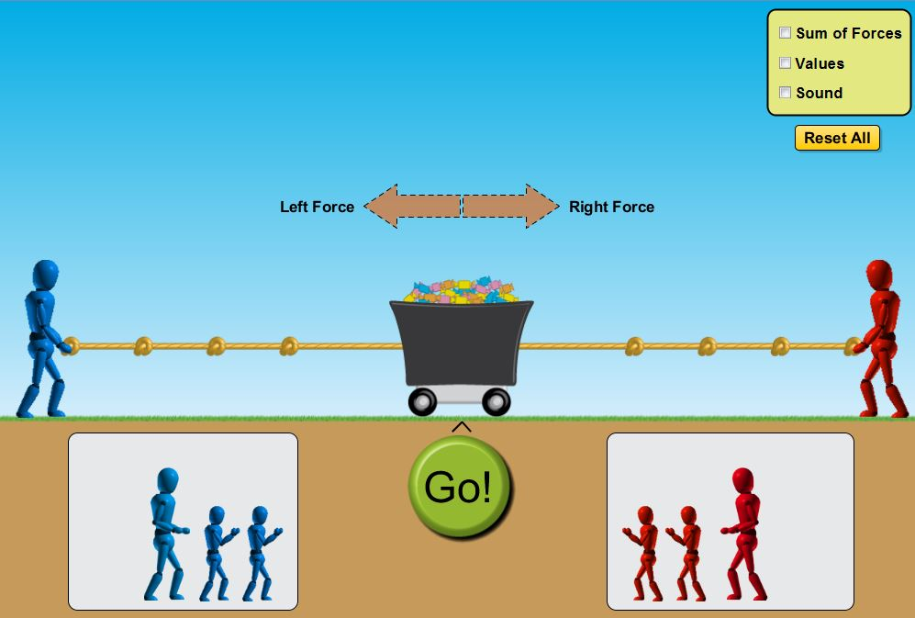
Observation and Analysis:

Set up your tug of war competition like the one seen in figure-1.

- What do the brown arrows represent ? _____________________________________________.

- Is one arrow larger than the other in this scenario? ____________________________________.

- Are they pointing in the same or different directions? _________________________________.

- Go to the menu screen and click the box titled “Values”.

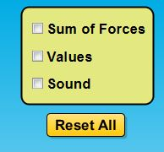
Describe what happened when you clicked the box.

____________________________________________________________________________.

- What is the value of: Left Force ____________ Right Force ____________

- Click the green “Go!” button and write down what you observe in the space below the picture.
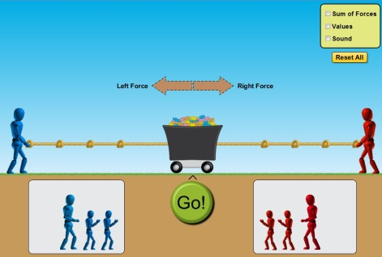

____________________________________________________________________________________________________________________________________________________________________________________
- Click the “return” button and move the blue figure so that it is positioned closer to the cart. Leave the red figure at the end of the rope. Did moving the blue figure cause a change in any of the forces acting toward the left? _____________________________________________________________________

- Click the box titled “Sum of Forces”. What are the “sum of forces” acting on the cart?

____________________________________________________________________________________

Figure-2
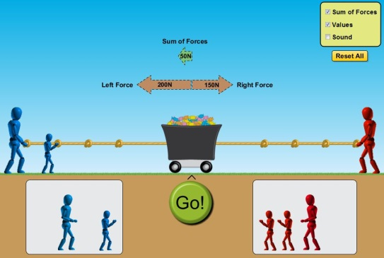
- Now add another blue figure to the left side of the cart.
How did the addition of another blue figure effect the
size of the “Left Force” acting on the cart? What amount
of force is on the “blue side” now? What is the
sum of forces acting on the cart?
___________________________________________

___________________________________________

- Discuss with your lab partner why you think subtraction was used to calculate the sum of the forces in the examples we’ve seen thus far? Record your explanation below.

________________________________________________________________________________________________________________________________________________________________________
- Make a prediction about what will happen when you click the green “Go!” button on Figure-2. Set up a simulation like that seen in Figure-2. Click the “Go!” button and describe what you observe. Did your observation match your initial prediction? Did the cart move in the direction of the greater force?

______________________________________________________________________________________________________________________________________________________________________________

Use the simulation to complete the table below:

 | Left Force  (N) | Right Force  (N) | Sum of Forces  (N) | Direction of cart movement once “GO!” is pressed.
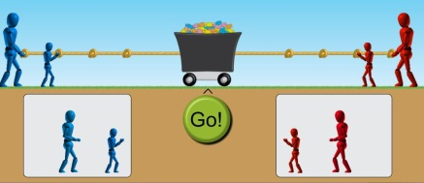

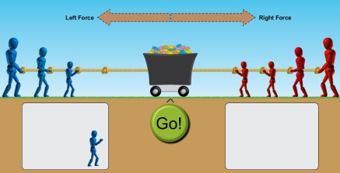

Summary:
- During the simulation, when the sum of forces acting on the cart equaled zero, did the cart move?
______________________________________________________________________________

- When the cart moved, were the forces acting upon it balanced or unbalanced? Explain.
____________________________________________________________________________________________________________________________________________________________________________________________________________________________________________________________

- When the cart moved, did it always move in the direction of the “sum of forces”?
___________________________________________________________________________________

- With your lab partner, write a summary of what you have learned today while performing the lab simulation on Forces and Motion.
____________________________________________________________________________________________________________________________________________________________________________________________________________________________________________________________________________________________________________________________________________________________________________________________________________________________________________________________________________________________________________________________________________________________________________________________________________________________________________________________________________________________________________________________________________________________________________________

Lab written and designed by Stephen N. Clontz, M. Ed
Email comments or suggestions: sclontz@whiteville.k12.nc.us
*Teachers, please email me and let me know if you used the lab. I’d welcome your suggestions and comments. This lab has been designed for minimal difficulty (remediation / concept introduction).

