**Projectile Motion II PhET Simulation Lab**

***Physics with pirates!***

**Introduction:**

In the previous simulation, all the projectiles left the ground and returned to the ground. We can use the same physics formulas to describe the motion of projectiles that leave the above or below the ground and may or may not return to the same height. We can also study the effect of a downward firing angle on a projectiles path.

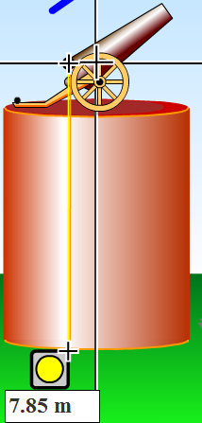

**Procedures:** *Play with the Sims 🡪 Physics 🡪 Projectile Motion*

*In most cases, you may use the simulation to check your work on math exercises.*

**Launching a Projectile with a non-zero Starting Height**

The tape measure can be used to measure not only distance but also height.

Play with the sim and observe the actions of a projectile that is not launched at ground level.

How does adding initial height affect **flight time**? _____________________________________

Why do you suppose this is? ______________________________________________________

What formula can we use that supports your explanation? _______________________________

How does adding initial height affect **maximum range**? ________________________________

Why do you suppose this is? ______________________________________________________

What formula can we use that supports your explanation? _______________________________

Consider this scenario and ignore air resistance. A pirate fires his cannon parallel to the water but 3.5 m above the water. The cannonball leaves the cannon with a velocity of 120 m/s. He misses his target and the cannon ball splashes into the briny deep. How far did the cannonball travel? *(please show work)*



A rival pirate fires his volley back at the same 3.5 m above the sea, but at an angle of 230. Coincidentally, this scurvy dog’s cannon also fires at 120 m/s. Also strangely coincidentally, this cannonball also misses and splashes into the sea. How far did this cannonball travel? *(please show work)*

**Firing a Projectile Downward (with a negative angle, θ)**

We can still resolve an initial velocity into vx and vy, even if our angle of launch is negative.

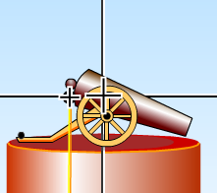What affect does a downward firing angle have on flight time? _________________________________________________________________________

Why do you suppose this is? __________________________________________________

What formula can we use that supports your explanation? ___________________________

How does this negative angle affect **maximum range**? ____________________________________________________________________________________________

Why do you suppose this is? _____________________________________________________________________

What formula can we use that supports your explanation? ______________________________________________

Back to our pirates. A small dingy is floating up to a pirate’s ship full of would be boarders. He angles his cannon downward at -150 while 3.0 m above the water. He fires his cannon at 95 m/s. The small boat of unfortunate crewmen is 20 m away. Do they survive their foolhardy errand? *(hint: to avoid using the quadratic, first calculate how long the projectile takes to strike the water using only vy) (please show work)*

**The Interrupted Projectile (that hits something on the way)**

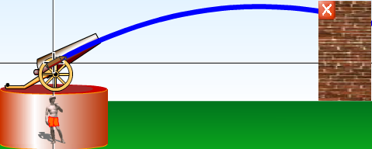Many projectiles don’t complete their entire travel to the ground. We may need to calculate the range of a projectile that lands on a hill above ground or the height when the projectile stuck its mark.

How would the flight time of a projectile that lands ABOVE the height it was launched compare to the flight time of a ground-to-ground projectile? ____________________________________________________________________________________________

Why is this? ___________________________________________________________________

What formula can we use that supports your explanation? _______________________________

OK, one last pirate scenario. A pirate 50.0 m away from a tall ship wants to shoot the crow’s nest off this ship. She angles her cannon at 250 and fires; her cannonball leaving at only 68 m/s. Somehow, the lass pegs the crow’s nest. How high was the crow’s nest? *(please show work)*