Forces and Motion

Introduction:
- The content of this investigation is to explore forces and motion by studying force, mass and acceleration.
- In Part I of Forces and Motion, you will explore the relationship between Mass, Force, and Acceleration.
- In Part II of Forces and Motion, you will investigate the acceleration of an object. Acceleration is the change in velocity (or speed) over the change in time. It is how quickly an object picks up speed.

In your writing your responses for this activity use scientific words such as, constant, increase, decrease, force, mass and acceleration.

Part I : Explore

Use the Forces and Motion simulation from
http://phet.colorado.edu/sims/html/forces-and-motion-basics/latest/forces-and-motion-basics_en.html. Your screen should look like the following. Click on motion.

Feel free to explore the simulation for 5 minutes

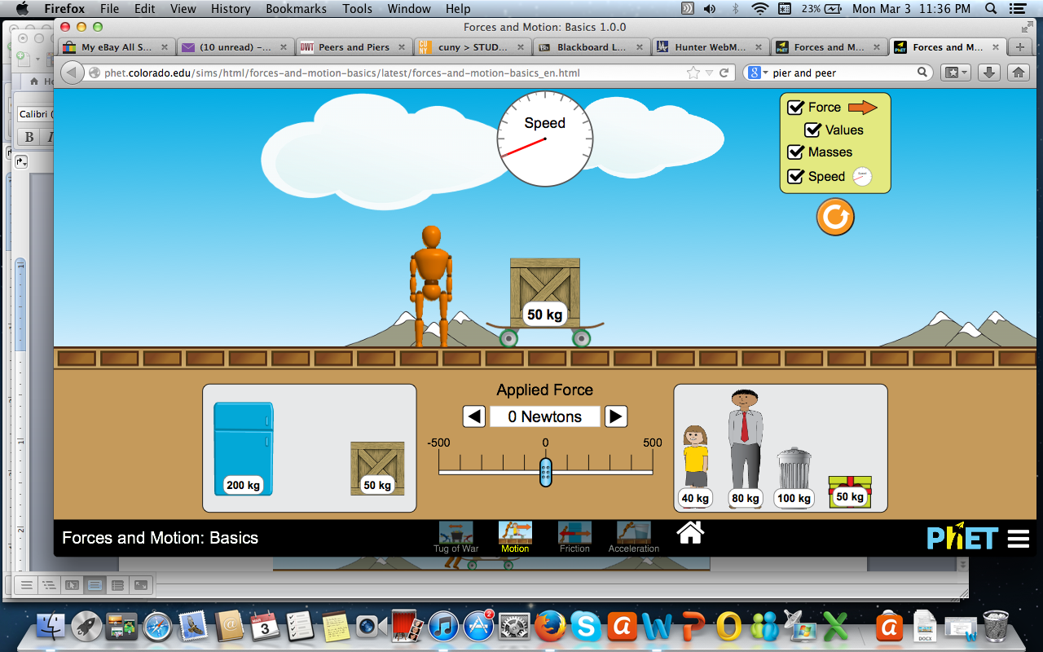

Before you begin to future explore, select the Forces, Values, Masses, and Speed checkboxes in the yellow box on the top right.

- Place the box on the skateboard. Set the applied force to 100N. Watch the speedometer as the box on the skateboard picks up speed.

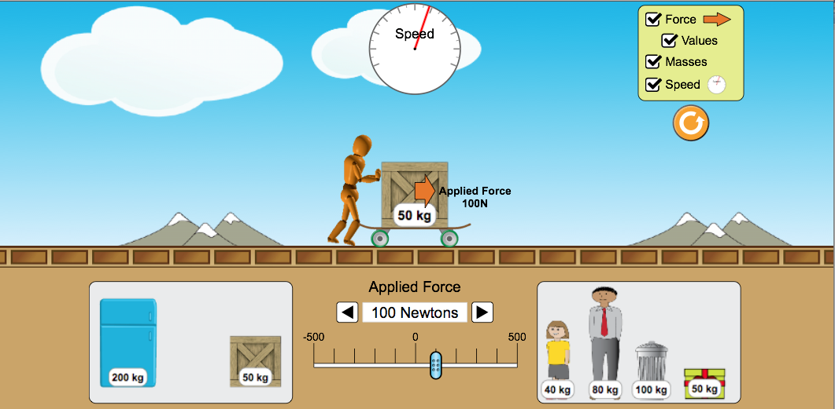

- Now place the refrigerator on the skateboard. Set the applied force to 100N and watch on the speedometer as it picks up speed.
  - What is the relationship between an object’s mass and its ability to pick up speed, or accelerate?

- What do you think the wooden man and arrow represent?
- What do you think the object or objects on the skateboard represent?
- What does the change in speed represent?
- Now put the box and refrigerator on the skateboard and set the amount of applied force to 100N. Predict if the acceleration will increase or decrease.

- Reset the scenario and check off Forces, Values, Masses, and Speed on the top right. Put the box back on the skateboard, but this time set the amount of force to 300N.
  - In your own words how would you describe the relationship between the amount of applied force and an object’s ability to pick up speed, or accelerate?

Part II: Explain
Newton’s Second Law

- The force acting on an object is equal to the object’s mass multiplied by its acceleration. This is known as Newton’s second law of motion, and is abbreviated F = MA. Force is in units of newtons, mass is in units of kilograms, and acceleration is in units of meters/second²
- In this section, we will investigate acceleration by using force and mass.

Part A: Constant with varying mass
Investigation
Set the force to 100N.
Increase the mass starting at 40kg, progressing towards 50kg, 80kg, 100kg, and 200kg.

Predict what will happen to the acceleration as the mass increase:

Fill in chart.
Investigate the acceleration using Newton’s second law (F=MA)
Mass (kilograms) | Force (Newtons) | Acceleration(meters/second²)
40kg | 100N
50kg | 100N
80kg | 100N
100kg | 100N
200kg | 100N

1. What do you notice happens as you increase mass?

2. Was your prediction correct? Explain.

Part B: Constant with varying force

Now set the mass to 100kg.
Start the applied force at 50N and slowly increment it in intervals of 50N.

Predict what will happen as you increase the force

Fill in chart.
Investigate Acceleration
Mass (kilograms) | Force (Newtons) | Acceleration(meters/second²)
100kg | 50N
100kg | 100N
100kg | 150N
100kg | 200N
100kg | 250N

2. What do you notice about the relationship between force and acceleration? Explain.

3. Was your prediction correct? Explain.

4. Where you surprised by anything in this activity? If so, what?

Apply:
Use your knowledge of acceleration to find the mass and force by dragging different objects to your skateboard and applying force.
Fill in chart.
Investigate Acceleration
Mass (kilograms) | Force (Newtons) | Acceleration(meters/second²)
 |  | 1
 |  | 2.2
 |  | 2.5
 |  | 4
 |  | 6

1. Was did you learn from this activity? Explain.

Congratulations! You have finished!

