Name: ________________________________________
Grade:_________________________________________

Gravity and Orbits

Pre-lab

1. Choose the picture you think shows the gravity forces on the Earth and the Sun.

(a longer arrow to represents a big force, and a shorter arrow represent a smaller force)

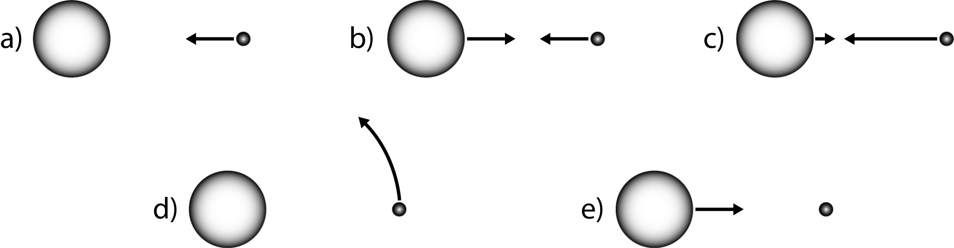

2. How would these gravity forces change if the Sun got much bigger?
Increase
Decrease
Stay the same

3. How would these gravity forces change if the Earth was much closer to the Sun?
Increase
Decrease
Stay the same

4. How would these gravity forces change if the Earth got much smaller?
Increase
Decrease
Stay the same

5. Choose the picture of how the Earth would move if you “turned off” the gravity forces.
