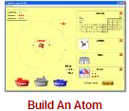**Build An Atom PhET Lab SOLUTIONS**

**Introduction:** Atoms are the smallest things that retain the properties of matter we can observe. Atoms are made of three ***subatomic*** particles; protons, neutrons, and electrons.

* Protons have a mass of ___________ unit and a charge of ___________.
* 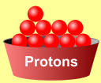Neutrons have a mass of ___________ unit and a charge of ___________.
* Electrons have a mass of nearly___________ unit and a charge of ___________.

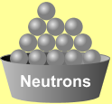In this simulation, you will build atoms, subatomic particle by subatomic particle and observe the effect of adding more of each particle. When the subatomic particles in an atom change, an **ion**, **isotope** or different element will be created.

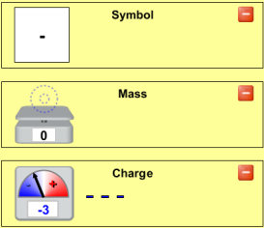**Procedure:** *Play with the Sims 🡪 Chemistry 🡪 Build An Atom* 

Begin by playing with the simulation for a while. Become familiar with the interface. What happens when you add protons, neutrons, or electrons? To start over, click .

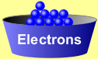Show the **symbol**, **atomic mass**, and **charge** by clicking on the .

**Analysis Questions**

1. Ions are atoms of the same element with different numbers of ____***electrons***_____.
2. Isotopes are atoms of the same element with different numbers of _____***neutrons***_______.
3. Adding or removing protons from an atom does what to the atom? _______***changes the atom or element’s identity***
4. An atom with the same number of protons and electrons has a charge of ____***0***____.
5. Adding two electrons to a neutral atom produces an ion with a charge of ____***-2***____.
6. An atom with six protons and five electrons would have a charge of ____***+1***____.
7. What atom is created with nine protons, nine neutrons, and nine electrons? ***Fluorine***



1. Show the full symbol for the above atom in the box at the right
2. What does the upper-left number in the symbol represent? _***mass, protons and neutrons***__
3. What does the lower-left number in the symbol represent? _***atomic #, protons***____
4. Draw the atoms described below, showing protons, neutrons, and electrons:

Hydrogen: H Carbon: C Oxygen: O Neon: Ne

|  |  |  |  |
| --- | --- | --- | --- |
|  |  |  |  |

**The Game**

With remaining class time, play a few games. Who in your lab group can get the highest score? WINNER: _______________

***Complete the table below***

Remember…when there are more electrons than protons, the charge should be: _____***negative***____.

And when there are more protons than electrons, the charge will be: ______***positive***_________.

|  |  |  |  |  |  |  |  |
| --- | --- | --- | --- | --- | --- | --- | --- |
| Protons | Neutrons | Electrons | Atomic Number | Mass Number | Charge | Element | **Full** Symbol |
| **4** | **4** | **4** | **4** | **8** | **0** | **Be** |  |
| **5** | **5** | **6** | 1.5 | 2.10 | 3.-1 | 4.B |  |
| **8** | **8** | **7** | 6.8 | 7.16 | 8.+1 | 9.O |  |
| 11.7 | 12.6 | 13.10 | **7** | **13** | **-3** | 14.N |  |
| 16.9 | 17.11 | 18.10 | **9** | **20** | **-1** | 19.F |  |

**Conclusion Questions (use a periodic table)**

1. All Zinc atoms have (how many?) __***30***__ protons.
2. If a Copper atom has no charge (neutral), it would contain (how many?) ___***29***__ electrons.
3. All atoms that have 14 protons are (what element?) _***silicon***____.
4. If an atom of Zinc has a mass of 64, it has (how many?) ___***34***___ neutrons.
5. Silver-108 has a mass of 108. This means that it would have (how many?) __***61***__ neutrons with its 47 protons.
6. (Sodium) has (how many?) ___***11***__ protons and (how many?) ___***12***__ neutrons for a total mass of 23.
7. A -1 ion of Bromine would have ___***35***__ protons and ___***36***__ electrons.
8. A +2 ion of Calcium would have ___***20***__ protons and ___***18***__ electrons.
9. To form an ion with a -2 charge, an atom of Sulfur would need to have __***18***___ electrons.
10. A neutral atom of Zinc-66 has __***30***___ protons, __***36***___ neutrons, and __***30***___ electrons.