**Name: ___­­­­­­­­­__________________________  
Class Period: _____________________________**

**Exploring Floating and Sinking**

**Learning Objectives:**

1. TEKS 5.5(A) classify matter based on physical properties, including relative density (sinking and floating).
2. Be able to rank the relative density of objects after observing their floating behavior
3. Be able to determine density of an object through measurement

**1. Play around with the sim.** What can you do? What happens? Talk about what you find with your partner.

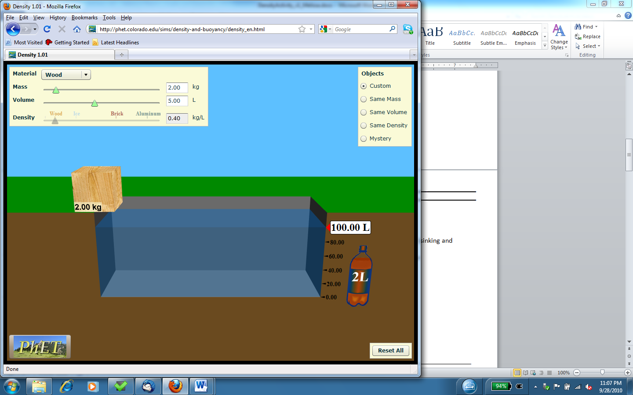

**2. Class Discussion: Share all the things you found that you can do with the simulation.**

**3. Exploring different materials and different sizes.**

a. Which materials sink? ______________________________________________________________

b. Which materials float? ______________________________________________________________

c. Keep exploring …

In your own words, what you think the label “Volume” means? __________________________________________________________________________

… and what you think the label “Mass” means? __________________________________________________________________________

d. Explore what happens when you make the block bigger and smaller.

Does the Mass change? _______

Explain why this makes sense: ___________________________

Does the Density change? ______

Explain why this makes sense: ____________________________

Does the floating or sinking change? ______________________________________________

**4. Design your own block!**

Experiment with **making your own block out of your own material** with “**My Object**”.

What properties of the block can you change?

What makes a block more likely to sink? How does this change the block’s density?

What makes a block more likely to float? How does this change the block’s density?

Try to create a block with a very **HIGH density.**

Do you think your block will sink or float? _____________

What is your block’s volume? __________________What is your block’s mass? __________________

Try to create a block with a very **LOW density.**

Do you think your block will sink or float? _____________

What is your block’s volume? __________________What is your block’s mass? ___________________

**5. Whole Class Discussion: Share what you discovered!**

**6. Your friend has three blocks (A, B, and C) of the same size, but they each float differently in water.**



a. What do you think is making them float differently? ____________________________________________________________________________________  
______________________________________________________________________________­­­­­______

b. Using “My Object”, check your answer by playing with your block to make it behave like A, then B, then C.

Which slider did you need to change?_______________________

Could A, B, and C be made out of the same material? Why or why not?

____________________________________________________________________________________________________________________________________________________________

Which object must have the most mass? _____

Which has the second most mass? _______

Which has the least amount of mass?________

**7. Test your ideas using the objects of “same volume”.**

a. All of these blocks are the same ______________.

b. Besides being different colors, the blocks also have different ____________________.

**8. Explore objects of the “same mass”.**

a. All of the blocks have a mass of _________ kg.

b. All of the blocks are different colors and different ______________.

c. Observe how they float. What do you notice? ____________________________________________

If all of the blocks have the same mass, why do you think some are floating and some sinking? ________________________________________________________________________________________________________________________________________________________________________

**9. Whole Class Activity:**

Draw our Density scale on the class whiteboard:

**Low Density Water High Density**

0 0.5 1 1.5 2 2.5 3 3.5

**Density (kg/L)**

Let’s figure out where to write these labels on the density scale:

**Sinks quickly**

**Barely sinks**

**Barely floats**

**Floats well**

**9. Calculating Density**

We can figure out the density of blocks using division if we know their volume and mass.

The equation is Density=Mass ÷ Volume. Let’s try this using the “mystery tab”!

|  |  |  |  |  |
| --- | --- | --- | --- | --- |
| **Object** | **Mass**  **(kg)** | **Volume**  **(L)** | **Density**  **(kg/L)** | **Sink or Float?** |
| **A** |  |  |  |  |
| **B** |  |  |  |  |
| **C** |  |  |  |  |
| **D** |  |  |  |  |
| **E** |  |  |  |  |