Purpose: Investigate the fields created by point charges when all other forces are ignored.
Apparatus: PhET Simulation Charges and Fields
Discussion: A point charge in space creates an electrostatic field, similar to a massive object creating a gravitational field. In fact, this similarity extends to the mathematical relationship between electrostatic force $F=k\frac{q_{1}q_{2}}{d^{2}}$ and universal gravitational force $F=G\frac{m_{1}m_{2}}{d^{2}}$. In this lab, familiarize yourself with how point charges create fields and how muliple fields, from multiple charges, interact.
It is worth noting that the field strength, E can be expressed in units of N/C and V/m.

Important Formulas:
Field Strength: $E=Fq$ and $E=Vd$ Electrostatic Force: $F=k\frac{q_{1}q_{2}}{d^{2}}$ k =9 .00x10⁹ Nm²/C²

Procedure and Analysis, part 1:
- Open your PhET Simulations: Electricity, Magnets, and Circuits → Charges and Fields
2. Place a single point charge in the work area and observe the field it creates with a test charge.
3. Draw the field lines (using convention, arrows) around a positive and (separately) a negative charge.

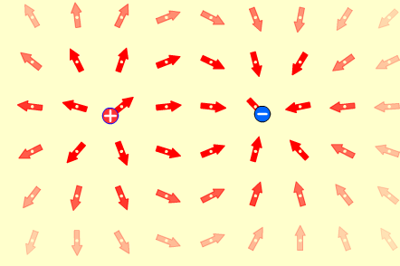

4. Draw the field lines around two nearby charges.

Two Positive Charges 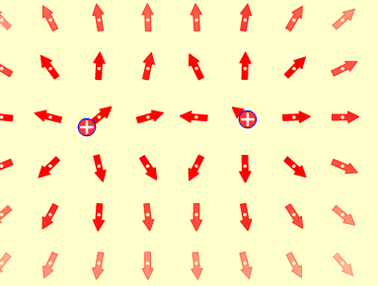

Two Negative Charges

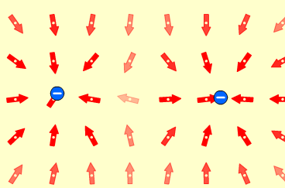

Positive and Negative Charges
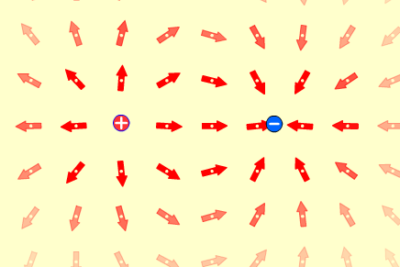

5. Where, around a point charge, is the magnitude of the electrostatic force the greatest? the least?

The field strength is displayed by the color/transparency of the arrow.
The force field is the greatest closest to the charge as evident by the solid red arrows, and decreases (least) the further away you go as evident by the transparent arrows. Remember: Field force is F=kq₁q₂/(d²) , so force is inversely proportional to the square of the distance.

6. Where, around a point charge, is the magnitude of the electrostatic potential the greatest?

For a positive test charge, the greatest potential occurs closest to the charge. (Similar to potential energy in Gravitational fields, work must first be done on an object such as raising a book. Work is required to move a positive charge closer to another positive charge. Since opposite charges repel each other, the potential is the greatest when the charges are the closest together (analogy: when spring is compressed the most or book is at highest position).

7. Using a single positive point charge, complete the table below:

Distance from charge, m | Field strength, V/m | Potential at location, V
2.1 m | ~2 V/m | ~4 V
0.90 m | 11 V/m | 10 V
0.99 m | 9 V/m | 9.0 V
0.35 m | 74 V/m | 26.4 V
2.81 m | 1.1 V/m | 3.2 V
0.58 m | 27.0 V/m | 15.8 V

8. Show, mathematically or with the formulas from your chart, that V/m = N/C.

Use the equations F=kq₁q₂/(d²) and E = F/q

So, for example with a distance = 2.1m, and a charge of 1nC (1x10⁻⁹)

E = F/q = kq₁/(d²) =(9.0x10⁹)(1x10⁻⁹) /(2.1 m)²

E = 2.0 N/C which is the same as Field Strength 2.0 V/m from table above

Conclusion Questions and Calculations:
- Closer to a point charge, the electrostatic field strength is stronger / weaker.

- Placed exactly between two oppositely-charged point charges, a test charge (the sensor) will show zero / minimum / maximum force.

- Placed exactly between two similar-charged point charges, a test charge (the sensor) will show zero / minimum / maximum force.

- Placed exactly on a point charge, the sensor will show zero / minimum / maximum field strength.

- A balloon is electrostatically charged with 1.4 μC (microcoulombs) of charge. A second balloon 23 cm away is charged with -2.1 μC of charge. The force of attraction / repulsion between the two charges will be:

Use the equations F=kq₁q₂/(d²)
So that F= kq₁ q₂/(d²) =(9.0x10⁹)(1.4x10⁻⁶) (-2.1x10⁻⁶) /(0.23 m)²
= -0.026/0.053
= -0.5 N

- If one of the balloons has a mass of 0.064 kg, with what acceleration does it move toward or away from the other balloon?
F=ma, therefore a=F/m

a = -0.5N/0.064 kg = -7.8 m/s²

- Imagine two 10. g objects hanging in standard earth gravity from 1.0m ultra-light strings, separated by 0.50m. Complete the chart below with free-body (force) diagrams to describe the effect on the objects under these circumstances:
Given: Mass = 0.01 kg, Length = 0.50 m, and k =9.0x10⁹

Assume acceleration due to gravity = 9.81 m/s²

Partial FBD shown below

Left object has a neutral charge, right object has a negative -1.0C charge | Left object has a positive +1.0C charge, right object has a -1.0C negative charge | Left object has a positive +1.0C charge, right object has a positive +1.0C charge
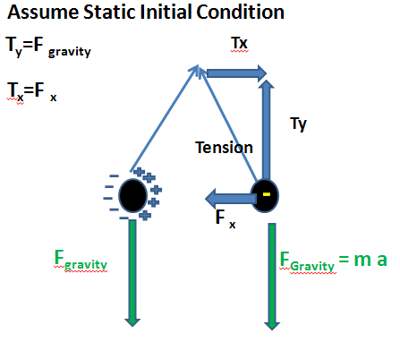 | 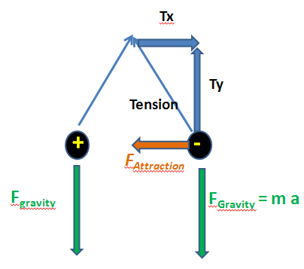 | 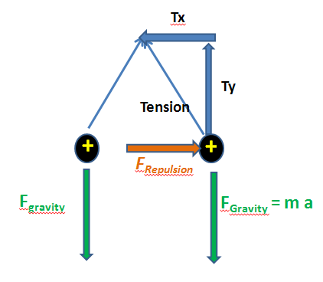

- For each of the above diagrams, calculate the initial force (before any movement from 0.5m away) of attraction/repulsion on each object.

Force due to gravity: F = ma,
Therefore, F = (0.01 kg) (9.81 m/s²) = 0.098N

Electrostatic Force: Use the equations F=kq₁q₂/(d²)
Case 2
So that F= kq₁ q₂/(d²) =(9.0x10⁹)(+1C) (-1C) /(0.5 m)²
= —3.6 X 10⁹
Case 3
So that F= kq₁ q₂/(d²) =(9.0x10⁹)(+1C) (+1C) /(0.5 m)²
= ⁺3.6 X 10⁹

- Does attraction due to universal gravity need to be included in your calculations above? Why/Why not?
No, due to the difference in order of magnitude between the forces (calculated above), gravity does not need to be considered. The electrostatic force is significantly stronger, such that the force of gravity can be neglected.

SUPPLEMENTAL ANSWERS:
Graphics for Problem 7
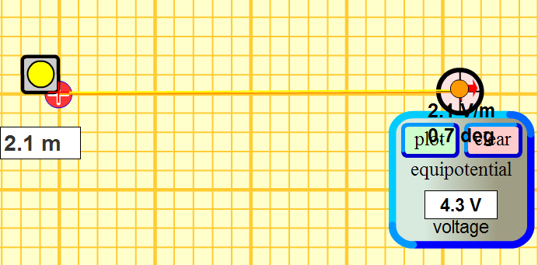

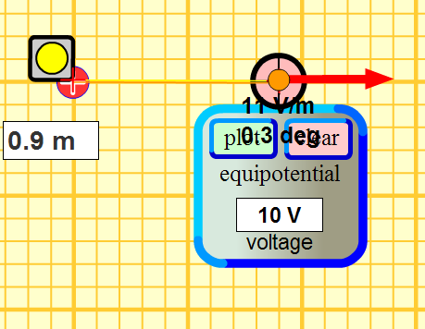
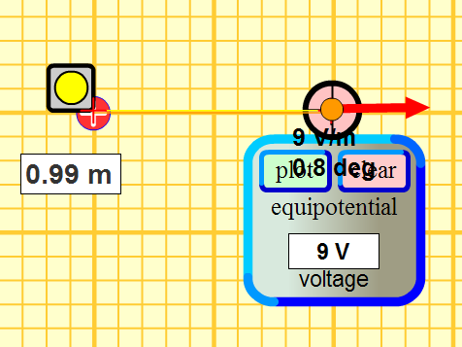
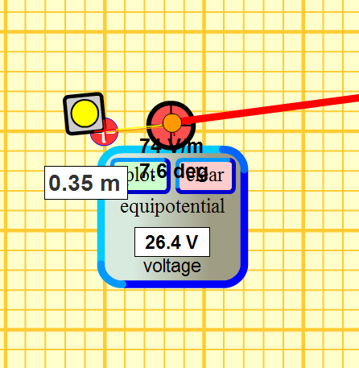
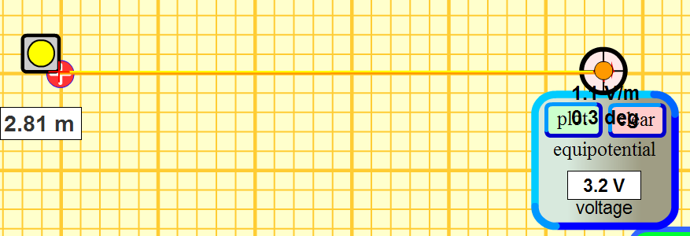

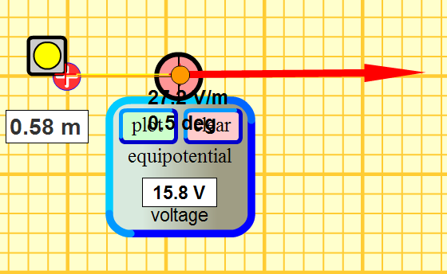

Reference: retrieved on 4/28/2011 at http://www.btinternet.com/~melee3d/revision/physics/chargefield.pdf
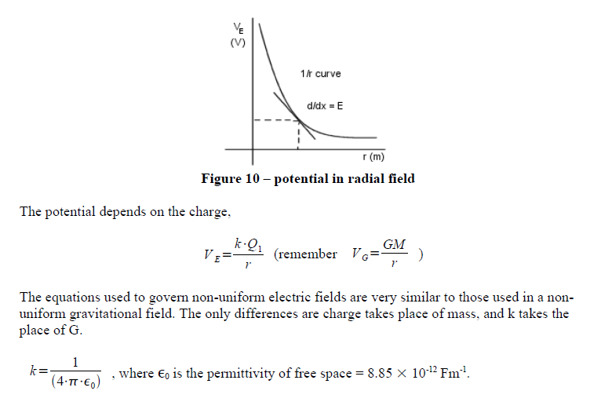

The following picture shows the test charge (sensor) between to oppositely charged particles:
